COMP396 FINAL REPORT
Honours year automated trading Project
Submitted by Team 02

Members: Ao Zhang, Haw Wong, Yixuan Zhao, Yudan Xue

Content
CHAPTER 1: FINAL STRATEGY SELECTION 2
1.1 OVERALL STRATEGY ARCHITECTURE 2
1.2 TRADING LOGIC OF SUB-STRATEGIES 2
1.3 CAPITAL ALLOCATION SCHEME 3
1.4 PARAMETER OPTIMISATION 4
1.5 ROBUSTNESS TEST 6
1.6 BACKTEST RESULTS ON PART 2 DATA 9
CHAPTER 2: RATIONALE FOR STRATEGY SELECTION 12
2.1 DATA ANALYSIS PROCESS 12
2.2 ASSET CLASSIFICATION METHODOLOGY AND RATIONALE 14
2.3 STRATEGY SELECTION DEMONSTRATION 16
2.4 POSITION MANAGEMENT RATIONALE 22
2.5 RISK MANAGEMENT DESIGN 23
2.6 KEY CODE EXAMPLES AND EXPLANATIONS 24
CHAPTER 3: EVALUATION OF PERFORMANCE ON PART 3 DATA 27
3.1 BACKTEST RESULT VS. EXPECTATIONS 27
3.2 ERRORS AND LIMITATIONS 32
3.3 LESSONS LEARNED AND IMPROVEMENT DIRECTION 33
BREAKDOWN OF THE TEAMWORK 35
YIXUAN ZHAO 35
AO ZHANG 35
HAW WONG 36
YUDAN XUE 36
REFERENCES 38

CHAPTER 1: FINAL STRATEGY SELECTION

1.1 OVERALL STRATEGY ARCHITECTURE
The project selected three sub-strategies for the development of the combined strategy: trend/momentum strategy, mean-reversion strategy, and short-selling strategy. These strategies jointly operate under a unified capital pool of £1,000,000, while simultaneously managing ten independent time-series assets, allowing all assets to operate within the same portfolio account. This structure enables both functional differentiation across strategy types and unified capital allocation and risk control.
In terms of the execution process, the combined strategy sequentially traverses the 10 assets on each trading day. Based on the predefined classification of each asset as trend-following, mean-reversion, or short-selling, the corresponding signal-generation method is used to generate buy, sell, or short signals. The resulting trades are then carried out through a unified order execution module.

1.2 TRADING LOGIC OF SUB-STRATEGIES
The three sub-strategies each have clearly defined applicable scenarios and entry-exit rules. The trend/momentum strategy was applied to series_1, 3, 4, 6, and 9, all of which share the common characteristic of having relatively high return-to-drawdown ratios (≥ 1.1), indicating that their price movements contain trend components that can be tracked and exploited. Within the trend strategy, three different variants were further adopted according to the volatility characteristics of individual assets: the breakout strategy, the above moving average confirmation (above_ma) strategy, and the moving average crossover (ma_crossover) strategy. The specific parameter settings and entry-exit conditions are reported in Table 1.1.
The mean-reversion strategy was applied to series_2, 7, 8, and 10. These assets have return-to-drawdown ratios below 1.1. Although they still generated positive returns, their drawdowns were deeper, suggesting that their price movements were more inclined to fluctuate around a mean rather than sustain a continuous trend. The mean-reversion strategy likewise adopted different variants according to asset characteristics, including the Z-Score strategy, the Bollinger Band strategy, and the RSI strategy.
The short-selling strategy was applied only to series_5. This series was the only asset in the dataset that exhibited a negative total return (-23.6%) (see Table 2-1 in Part 2). A traditional long-only strategy would therefore inevitably incur losses on this asset. Accordingly, an RSI overbought short-selling approach was adopted to profit from falling prices.

1.3 capital allocation scheme
The Combined Strategy adopts a trend-priority with equal weighting within groups capital allocation scheme. As shown in Table 1.2, the five trend/momentum assets are collectively allocated 70% of the total capital, with each asset receiving a weight of 14%. The remaining five assets, consisting of four mean-reversion assets and one short-selling asset, are collectively allocated 30% of the capital, with each asset receiving a weight of 6%.
This allocation reflects the empirical finding that the trend strategy is the primary source of portfolio returns. When run independently, the trend component generated a standalone return of 27.21%, whereas the mean-reversion and short-selling components together produced an overall standalone loss of -2.67%. However, despite their weaker standalone profitability, incorporating these non-trend strategies into the combined portfolio improved its risk-adjusted performance, increasing the Aggregate PD Ratio from 2.34 to 2.44.
The equal-weighting design within each strategy group follows the diversification principle proposed by Markowitz (1952). In the absence of sufficiently reliable predictive signals, this approach helps avoid excessive concentration in any individual asset within the same group, thereby reducing concentration risk and mitigating the potential for overfitting.

1.4 PARAMETER OptimiSation

1.4.1 OPTIMISATION METHODOLOGY
Parameter optimisation was conducted using a grid search approach, in which the full parameter space of all candidate strategy variants was exhaustively explored for each asset independently. The procedure was as follows. For each asset, its category identified in Section 2.2, namely trend-following, mean-reversion, or short-selling, was first used to determine the full set of candidate strategy variants within that class. Four variants were considered in each case. All parameter combinations for each variant were then systematically enumerated. Parameters were fitted on the training set and evaluated on the testing set. Finally, the globally optimal strategy-parameter combination was selected for each asset based on a composite scoring function.
To reduce the risk of overfitting, the 1,000 trading days were split chronologically into a training set consisting of the first 700 days (70%, from 2072-09-03 to 2074-08-03) and a testing set consisting of the remaining 300 days (30%, from 2074-08-04 to 2075-05-30). All parameters were fitted exclusively on the training set, while the testing set was reserved strictly for out-of-sample evaluation. The evaluation function adopted a multidimensional composite score defined as follows:
where $S$denotes the Sharpe ratio, $R$denotes return (%) and $D$denotes maximum drawdown (%). The clip function constrains each metric within a reasonable range to prevent extreme values from dominating the final score.

1.4.2 PARAMETER SEARCH SPACE
For the trend/momentum strategies, the search space was defined over the five trend assets, namely series_1, series_3, series_4, series_6, and series_9. For each asset, the full parameter space of the following four strategy variants was explored.
The total search space for each trend asset was therefore approximately 787 parameter combinations, giving a total of about 3,935 independent backtests across the five trend assets. For the mean-reversion strategy, the parameter search space was defined over the four mean-reverting assets (series_2, 7, 8, and 10). For each asset, the full parameter space of the following four strategy variants was exhaustively explored.
Each mean-reversion asset is evaluated across approximately 436 parameter combinations, giving a total of about 1,744 independent backtests across the four mean-reverting assets. For the short-selling strategy, the parameter search space was defined for the single short asset, series_5, by exhaustively exploring the full parameter space of the following four short-strategy variants.
In total, series_5 is evaluated across approximately 170 parameter combinations. Taking all three strategy categories together, the entire parameter optimisation process involved approximately 5,849 independent backtests, and each backtest included two complete strategy simulation runs, one on the training set and one on the testing set.

1.4.3 OPTIMISATION RESULTS
Table 1.3d summarises the optimal results for each asset obtained from the grid search. As can be seen from the table, the optimal strategy variant and parameter configuration differed across assets. For example, although the ma_crossover strategy for series_4 achieved a higher return on the testing set, the ma_deviation strategy for series_7 produced a Sharpe ratio of 1.52 and a maximum drawdown of only -0.44% and therefore obtained the highest composite score (0.691) instead. This reflects the emphasis of the scoring system on risk-adjusted returns. It should be noted that the parameters ultimately adopted in the final strategy were manually adjusted and were therefore not fully identical to the purely optimised results reported in the table. The specific reasons for these adjustments are discussed in detail in Section 2.3.

1.5 ROBUSTNESS TEST

1.5.1 OUT-OF-SAMPLE VALIDATION
To verify the strategy’s generalisation ability on unseen data, the full dataset was divided chronologically into an earlier period (2072-09-03 to 2074-03-01, approximately 54%) and a later period (2074-03-01 to 2075-05-30, approximately 46%), and the strategy was run separately on each period. As shown in Table 1.4, the strategy achieved a return of 14.71% and an Aggregate PD Ratio of 1.92 on the validation set. Although these figures were lower than the 19.55% return and 2.44 Aggregate PD Ratio obtained on the full dataset, the strategy still maintained positive returns and a risk-adjusted return close to 2.0, indicating that it had good out-of-sample generalisation ability and did not severely overfit the training data.

1.5.2 parameter Sensitivity ANALYSIS
To examine how sensitive strategy performance was to the capital allocation scheme, five allocation scenarios were tested, with the trend/other asset split ranging from 50/50 to 90/10. As shown in Table 1.5, as the trend allocation increased from 50% to 90%, the return increased steadily from 12.97% to 26.31%, which is consistent with the conclusion that the trend strategy was the main source of portfolio returns. More significantly, the Aggregate PD Ratio remained within the narrow range of 2.38 to 2.46 across all allocation schemes, with a variation of less than 3.3%. This suggests that the portfolio’s risk-adjusted return was not highly sensitive to the allocation parameter. Figure 1-1 illustrates this relationship more intuitively, and the current 70/30 allocation lies close to the peak of the PD Ratio. This result strengthens confidence in the stability of the strategy on unseen data, because even if the actual optimal allocation differs from the current setting, the impact on overall risk-adjusted performance would still be very limited.
Figure 1-1: Sensitivity Analysis of Capital Allocation — Dual-Axis Comparison of Return and PD Ratio
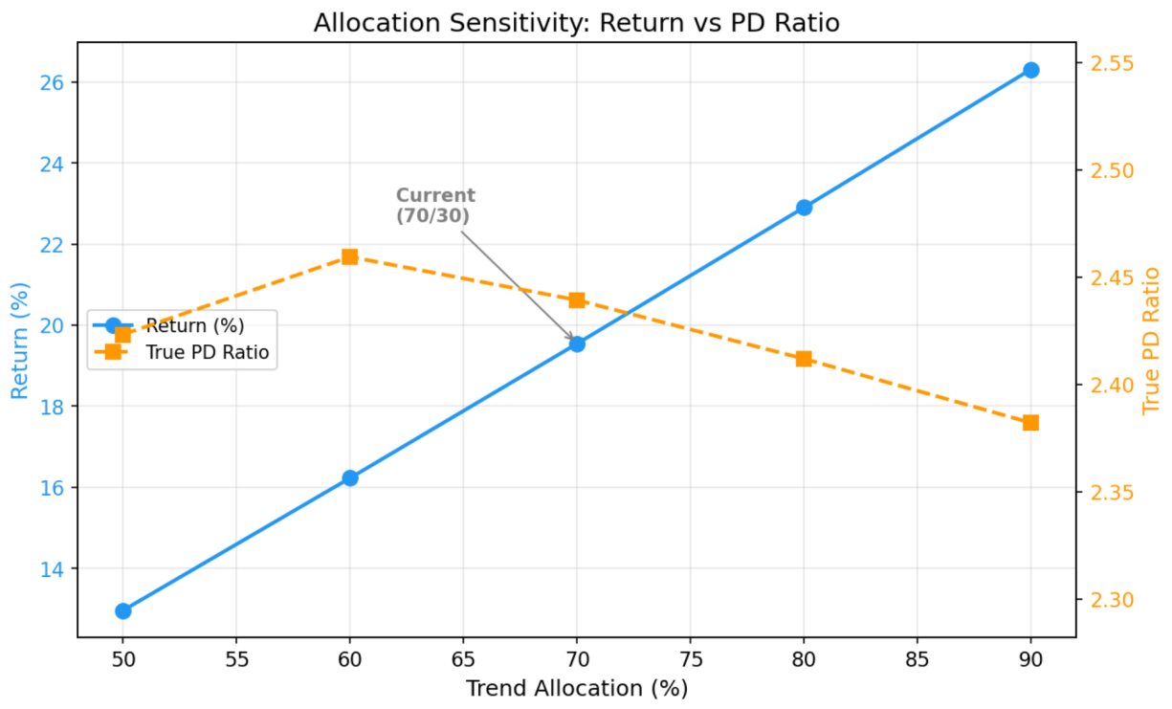

1.5.3 ROLLING WINDOW TEST
The rolling window test was conducted using a 6-month window length and a 3-month step interval. This produced 10 overlapping test windows over the full sample period and was used to examine the consistency of strategy performance across different market phases. As shown in Table 1.6, 9 out of the 10 windows produced positive returns, resulting in a profitable window ratio of 90%, while the average return was 4.65%. The only loss-making window was W1, which corresponded to the first six months of strategy operation, when trends had not yet fully developed, and the strategy was still in the signal accumulation stage.
The returns varied considerably across windows, ranging from -2.30% to 16.86%, with a standard deviation of 5.99% (Table 1.6b). The highest return windows, W6 and W7, achieved returns of 16.86% and 12.96%, respectively (Table 1.6), corresponding to the period in the second year when trends were most clearly established. Although returns fluctuated substantially across windows, the 90% profitable-window ratio indicates that the strategy was able to maintain positive returns in the vast majority of market environments, suggesting that the strategy had reasonably strong stability over time.
Figure 1-2: Return Distribution of the Rolling Window Test
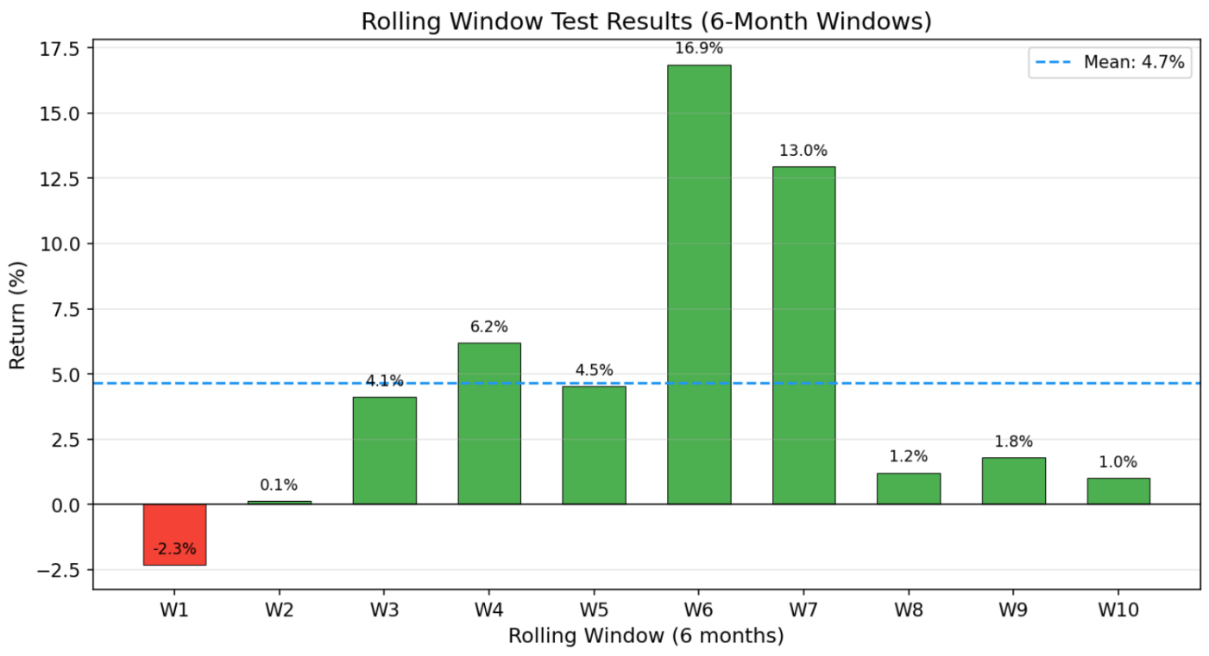

1.5.4 INDEPENDENT TESTing OF STRATEGY COMPONENTS
To quantify the contribution of each strategy component to the overall portfolio performance, a “trend-only strategy” (100/0 allocation) and an “other-strategies-only” portfolio (0/100 allocation) was run separately and compared with the current 70/30 mixed allocation. As shown in Table 1.7, the trend-only strategy achieved the highest return, at 27.21%, but its Aggregate PD Ratio was 2.34. By contrast, the other-strategies-only portfolio generated a loss of -2.67%, with a negative PD Ratio of -0.47. The current 70/30 mixed allocation produced a return of 19.55%. Although this was lower than that of the pure trend strategy, its Aggregate PD Ratio reached 2.44, representing the best risk-adjusted return among the three alternatives.
This result indicates that the mean-reversion and short-selling strategies generated an overall loss when run on a standalone basis. However, once incorporated into the combined portfolio, they improved risk-adjusted returns through diversification. In addition, the mixed portfolio achieved an Activity level of 96.90%, higher than the 94.19% recorded by the pure trend strategy. This suggests that the inclusion of mean-reversion and short-selling strategies increased the portfolio’s market participation and enabled capital to be utilised more fully.
Figure 1-3 presents a grouped bar chart that visually compares the three strategy combinations in terms of return and PD Ratio. As can be clearly seen from the figure, the trend-only strategy has the highest return bar (27.21%), but its PD Ratio bar (2.34) is lower than that of the 70/30 mixed strategy (2.44). The other-strategies-only portfolio has a negative return bar (-2.67%) and a negative PD Ratio (-0.47), indicating that this portfolio generates an overall loss when operated independently. The 70/30 mixed allocation achieves a better balance across the two dimensions.
Figure 1-3: Independent Testing of Strategy Components — Comparison of Return and PD Ratio
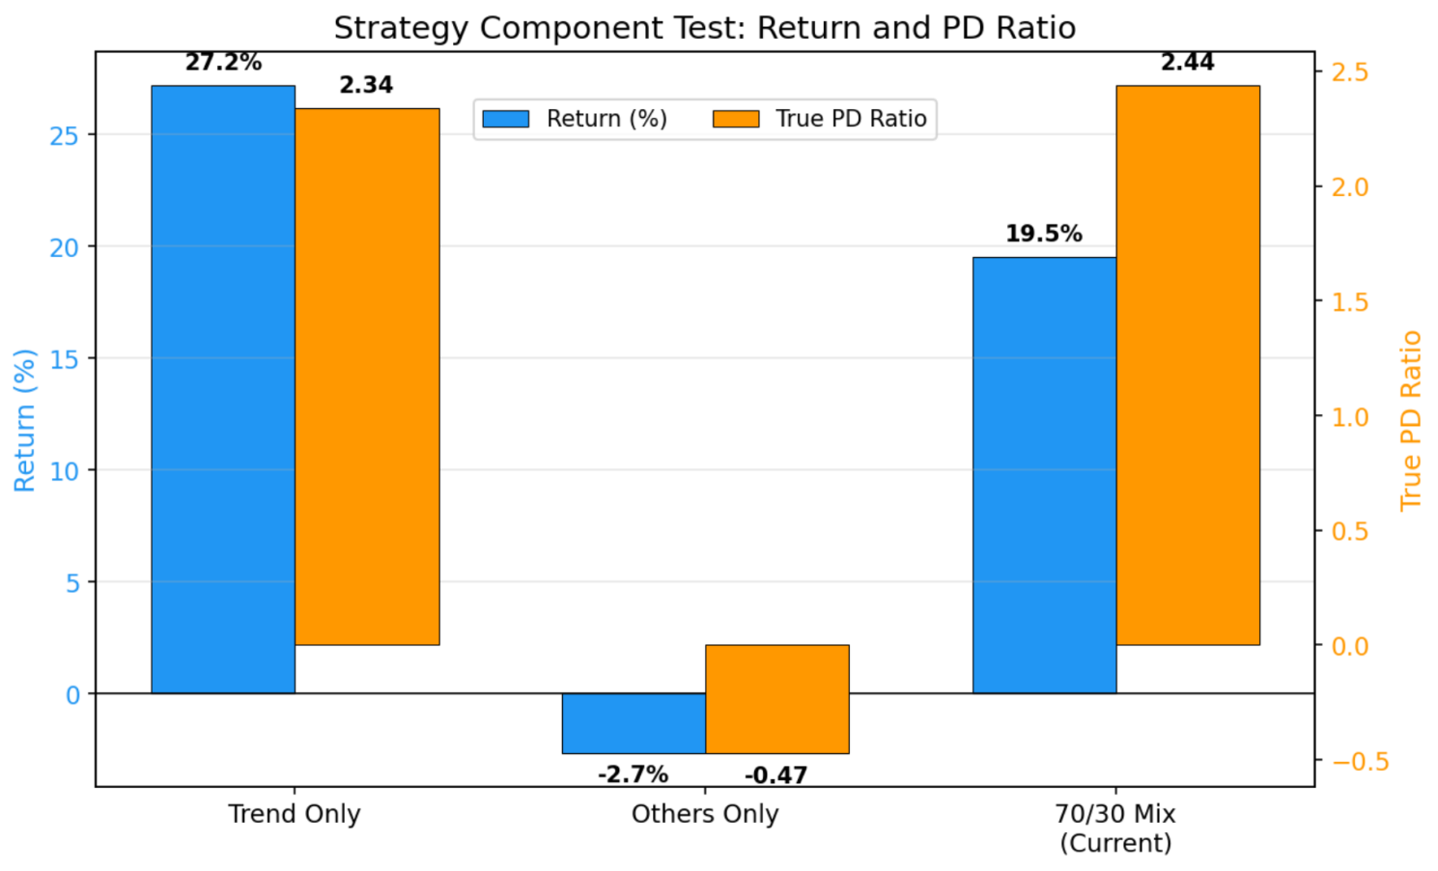

1.6 backtest results on part 2 data
After running the combined strategy on the full Part 2 dataset, the initial capital increased from 1,000,000 GBP to 1,195,452.14 GBP, representing a total return of 19.55%. As shown in Table 1.8, the Aggregate PD Ratio was 2.44. This metric incorporates both slippage costs (s_mult = 2.0) and forced liquidation at the end of the backtest (end_policy = liquidate) in its calculation and therefore provides a realistic measure of the strategy’s actual risk-adjusted performance. The Open PnL PD Ratio was 2.94, slightly higher than the Aggregate PD Ratio, with the difference arising from slippage losses incurred during liquidation. The strategy achieved an Activity level of 96.90%, meaning that the portfolio maintained at least one open position on almost all trading days, indicating a high level of capital utilisation. Throughout the entire backtest period, the portfolio value never fell below zero, and the bankruptcy mechanism was therefore never triggered.
Figure 1-4: True Equity Curve
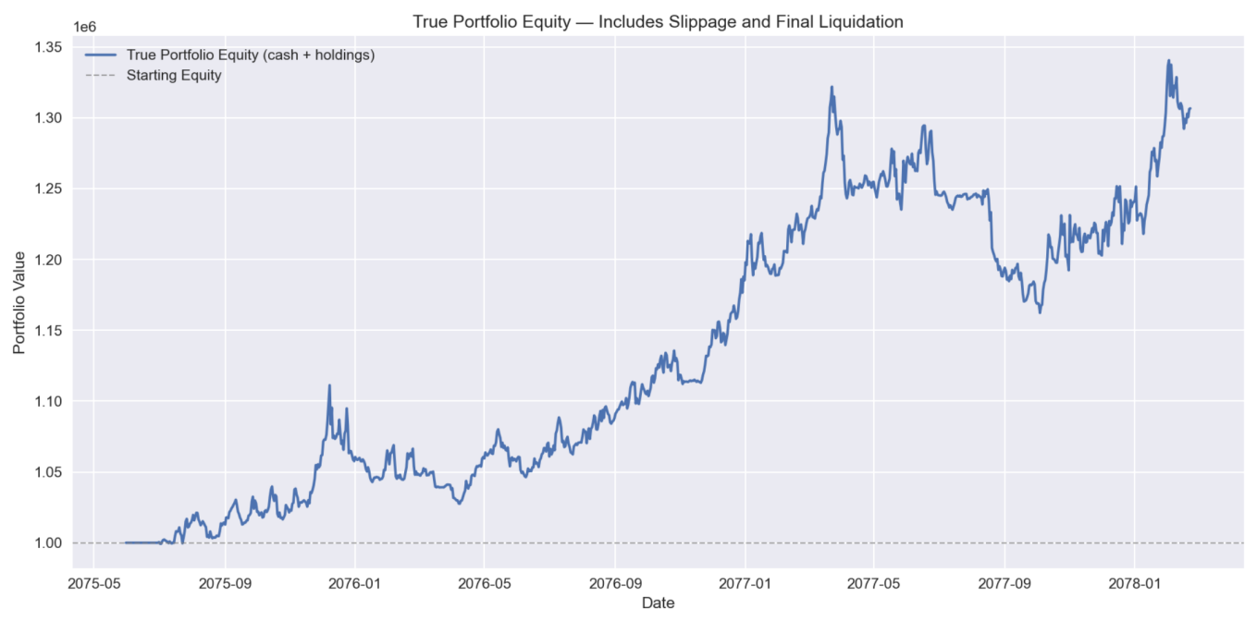
Figure 1-4 shows the True Equity Curve of the strategy. From the shape of the curve, it can be observed that the portfolio value remained broadly flat during the first 300 trading days (approximately the first year), then experienced a sustained upward trend between trading days 400 and 700 (approximately the second year) and finally stabilised after trading day 700. This pattern is consistent with the annual breakdown reported in Table 1.4: the second year contributed the majority of total return (16.63%), whereas the returns in the first and third years were relatively limited.

Figure 1-5: Portfolio Underwater Chart
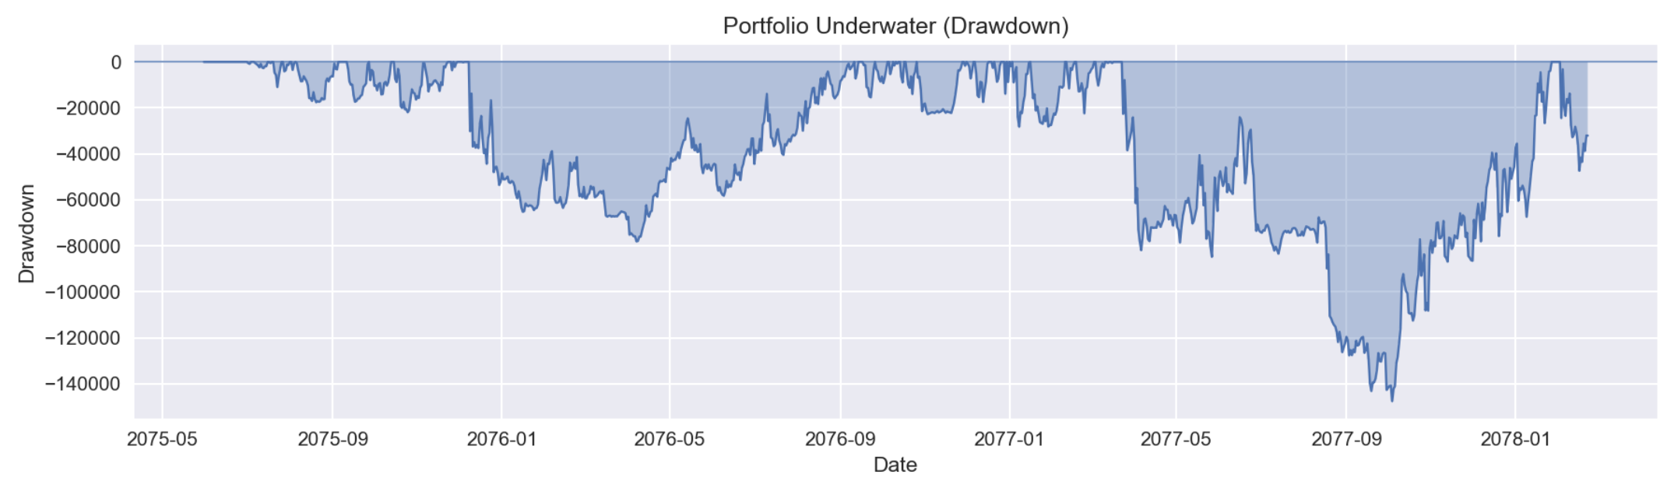
Figure 1-5 presents the portfolio’s Underwater Chart. Overall, the portfolio’s maximum drawdown remained within a reasonable range, and no prolonged period of deep drawdown was observed.

CHAPTER 2: RATIONALE FOR STRATEGY SELECTION

2.1 DATA ANALYSIS PROCESS
Part 2 Dataset has 10 independent assets. It covers 1,000 trading days, or about 3.97 years. Table 2-1 shows that these 10 assets have very different statistics. Total returns go from -23.57% (series_5) to 83.03% (series_4). The gap is over 100 percentage points. Daily volatility is between 0.16% (series_7) and 2.77% (series_4). The highest is 17 times larger than the lowest. Sharpe ratios include both positive and negative numbers, from -0.71 to +0.80. Regarding return distributions, series_1 and series_6 show significant positive skewness (4.10 and 3.70) and extremely high kurtosis (61.06 and 69.65), which means frequent extreme positive jumps in their price movements. On the other hand, series_7 and series_8 have negative skews (-1.92 and -1.28). These assets tend to have sudden price drops.
Figure 2-1 shows the price movements of the 10 assets. Series_4 has the clearest uptrend, but it also has high volatility and deep drawdowns. Series_3 grows less than Series_4, but its price moves very smoothly. It is the most stable asset in an uptrend. Series_5 is the only asset that goes down constantly during this period.These differences help us classify the assets and design different strategies for each. Research by Brock, Lakonishok, and LeBaron (1992) shows that we can capture more profit if we match specific trading rules to different price patterns.
Figure 2-1: Price Trends of the 10 Assets
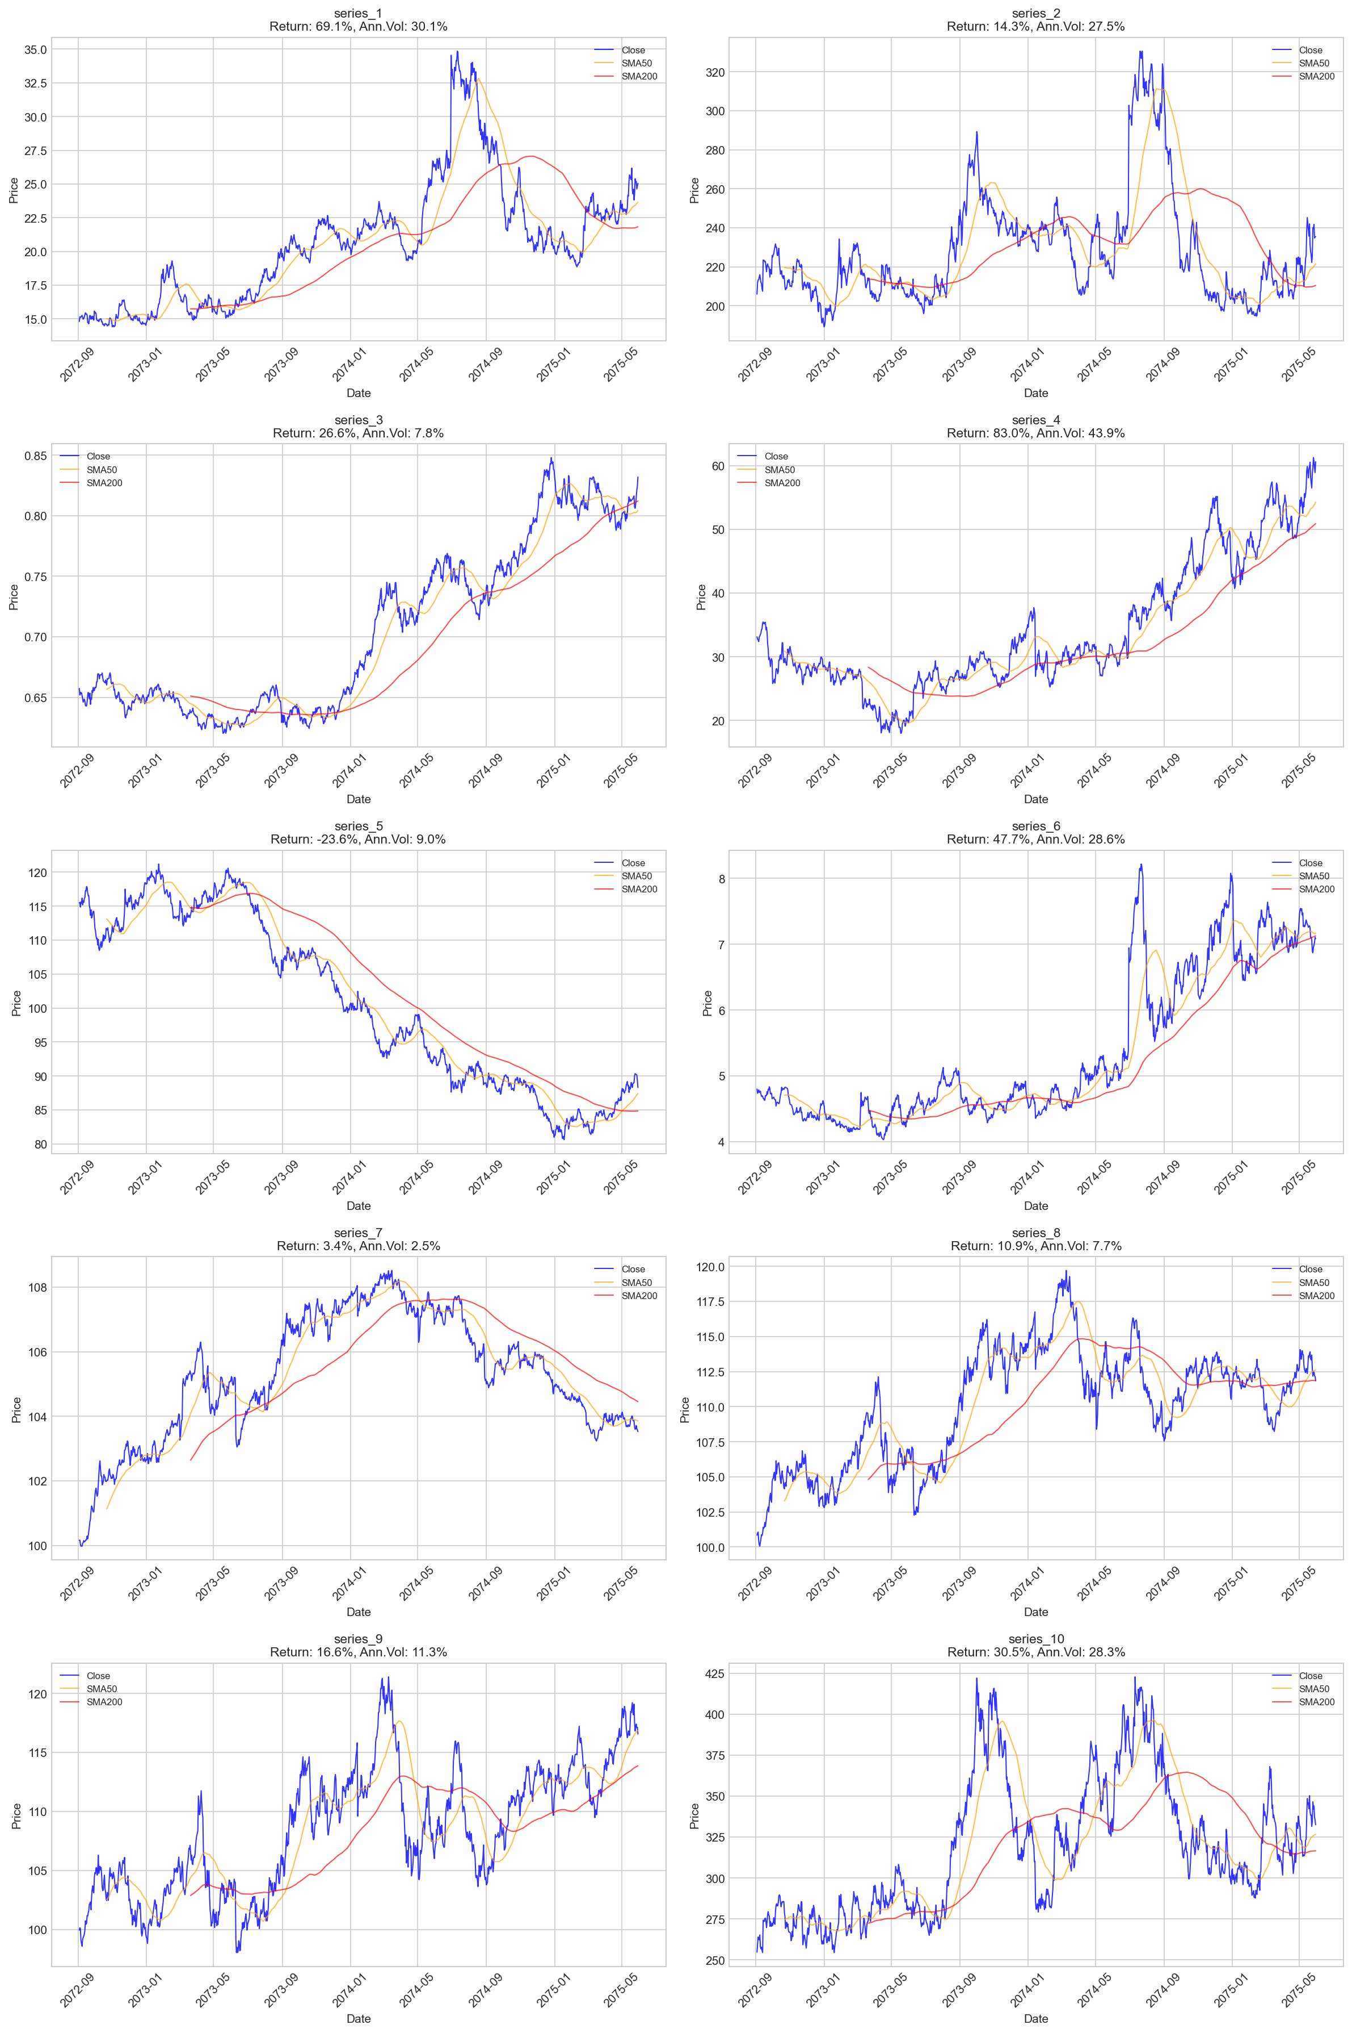
Figure 2-2 compares the relative performance strength of the 10 assets. The team normalizes all starting prices to 100. This step removes the effect of different price levels. This way, assets of all sizes can be compared directly on one chart. The chart shows that normalized price of series_4 rose to about 183 by the end. It is the strongest performer in the group. Normalized price of Series_3 and series_1 also show steady uptrends. But normalized price of series_5 fell to around 76. It is the only asset to end with a value lower than its starting point. This chart confirms the total return rankings in Table 2-1.
Figure 2-2: Normalized Price Comparison (Base = 100)
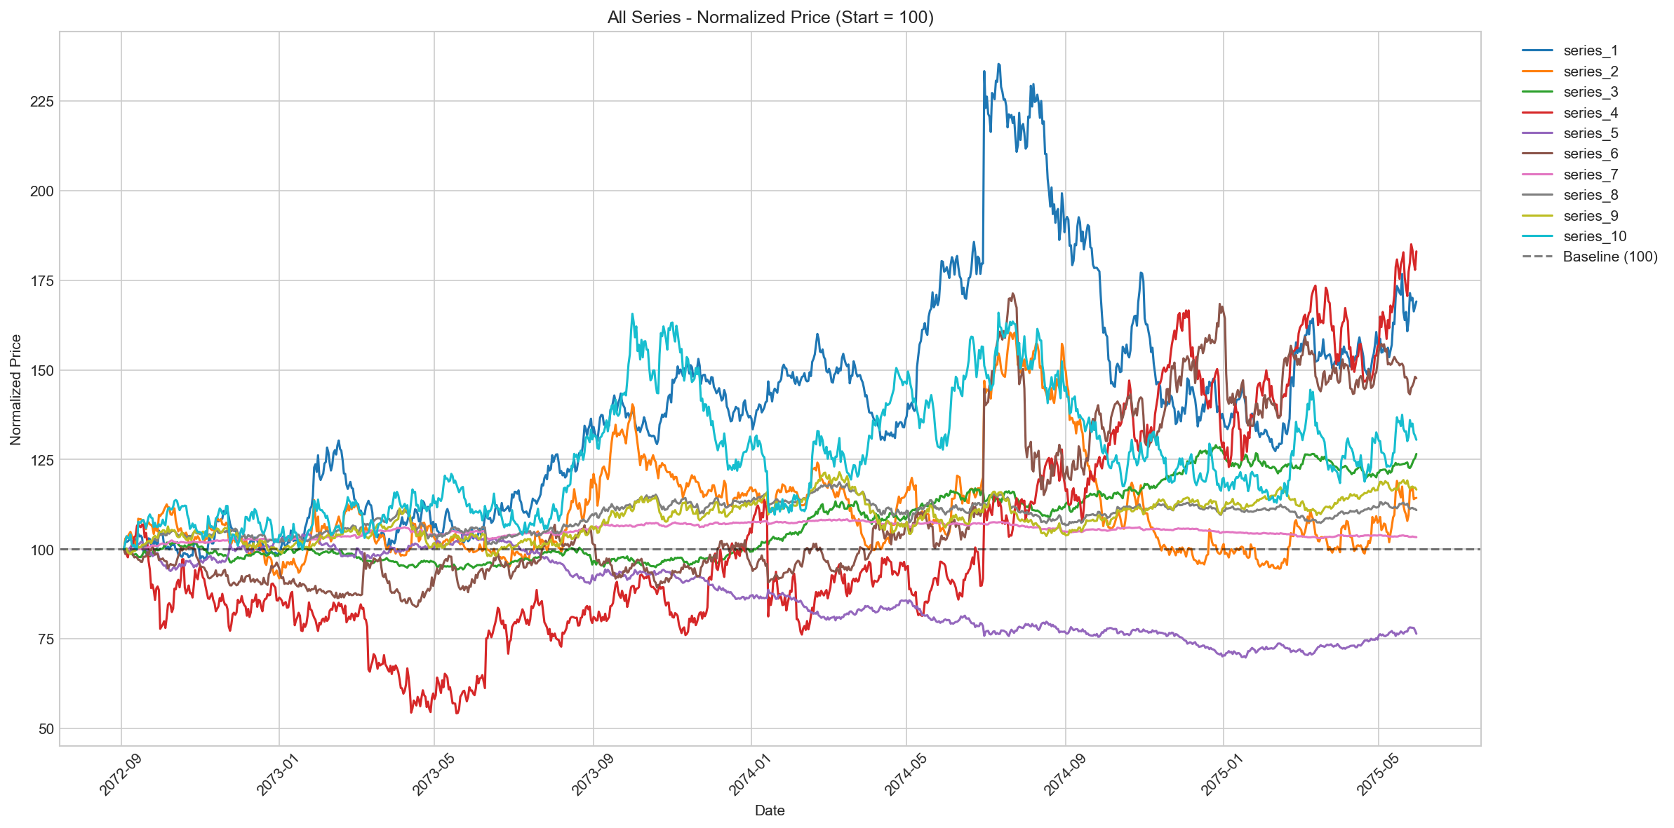
Figure 2-3 shows the histograms of daily returns for 10 assets. These return distribution shapes match the data in Table 2-1. Series_1 and series_6 are right-skewed and have high peaks. This matches their high skewness and kurtosis scores. It shows that their prices often jump up suddenly. On the other hand, series_7 and series_8 are left-skewed and have "fat tails." This reflects their negative skewness and high kurtosis. These different shapes help in creating better strategies for each asset later.
Figure 2-3: Distribution of Daily Returns for the 10 Assets
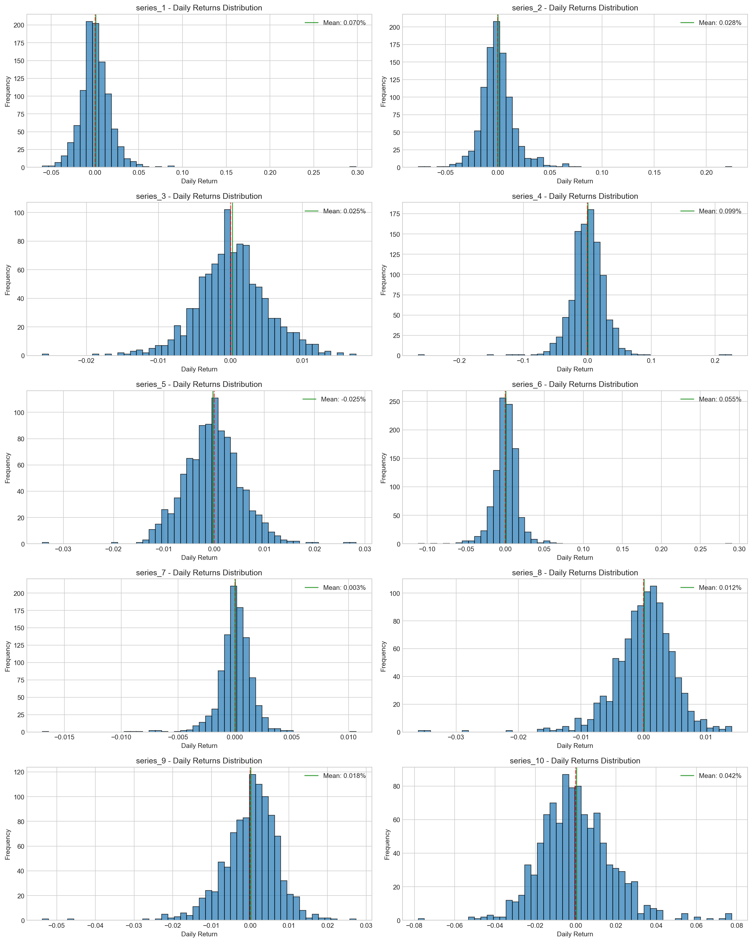

2.2 ASSET CLASSIFICATION METHODOLOGY AND RATIONALE
After confirming the significant differences among 10 assets, the next step is to establish a systematic classification method to assign each asset to its most suitable strategy type. The team uses the "Return/MaxDD Ratio" as the main index for classification. This ratio is better than simple return or volatility. It can measure both profit and downside risk at the same time. A high Return/MaxDD Ratio indicates that the trend component in the price movement is strong enough to compensate for drawdown losses, making the asset ideal for trend-following strategies. Conversely, an asset with a lower ratio may still generate positive returns but suffers deeper drawdowns; its price mostly bounces around an average, making it better suited for mean-reversion strategies (Poterba & Summers, 1988).
The classification threshold is 1.1. The rule is simple: if an asset has a negative total return, it goes into the short-selling category. For the remaining assets, if the Return/MaxDD Ratio is ≥ 1.1, it is assigned to the trend/momentum strategy category; if the ratio is < 1.1, it goes into the mean-reversion strategy category. The 1.1 threshold comes from looking at the data. Table 2-2 shows that assets naturally fall into two groups. Assets with a ratio of 1.1 or higher make up the trend group. Assets with a ratio below 1.1 make up the mean-reversion group. Series_9 (1.14) and series_8 (1.07) are very close to this limit. Even so, backtest shows that this division works well. Assigning series_9 to the trend group and series_8 to the mean-reversion group leads better performance under their respective strategies than if we had swapped their classifications. Finally, series_5 is placed independently in the short-selling category due to its negative total return of -23.6%.
Sharpe Ratio

The final classification results in: 5 trend/momentum assets (series_1, 3, 4, 6, 9), 4 mean-reversion assets (series_2, 7, 8, 10), and 1 short-selling asset (series_5).
Figure 2-4: Asset Classification Scatter Plot — Total Return vs. |Maximum Drawdown|
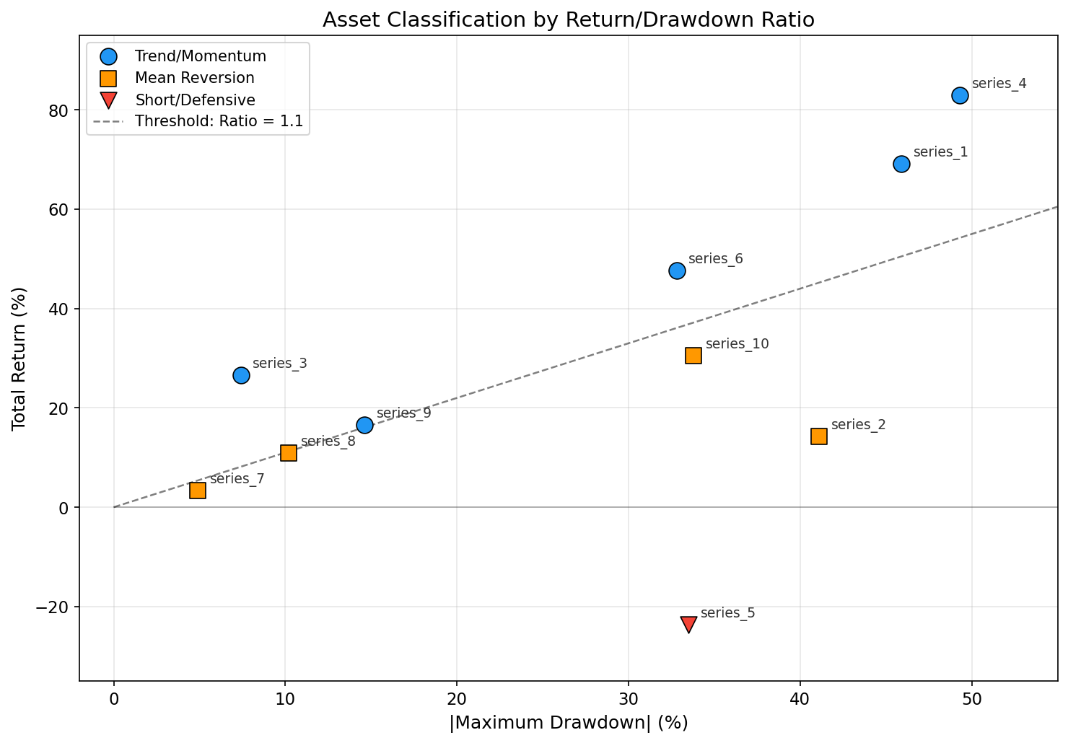
Figure 2-4 shows the asset classification results in a scatter plot. The black dashed line marks the Return/MaxDD Ratio threshold of 1.1. Assets above this line go into the trend group. Assets below the line go into the mean reversion group. As the chart shows, series_3 is the furthest from the line with a ratio of 3.57. This means its trendy features are the most obvious. Meanwhile, series_9 (1.14) and series_8 (1.07) sit right on opposite edges of the threshold. This confirms the discussion in Section 2.2 about classifying assets near the boundary. Series_5 lies below zero on the return axis, making it the only asset assigned to the short-selling strategy.

2.3 Strategy selection DEMONSTRATION
This part will demonstrate why a specific strategy variant was chosen for each asset, including asset characterization, strategy matching rationale, and a description of the differences from the optimizer's recommended results. It is important to note that not all the strategy variants adopted were derived from the optimal results of the grid search (Table 1.3d), and some assets were manually adjusted to balance the pursuit of optimal performance within the sample with the ability to generalize outside the sample.
Figure 2-5: Examples of buy and sell signals for three strategy types
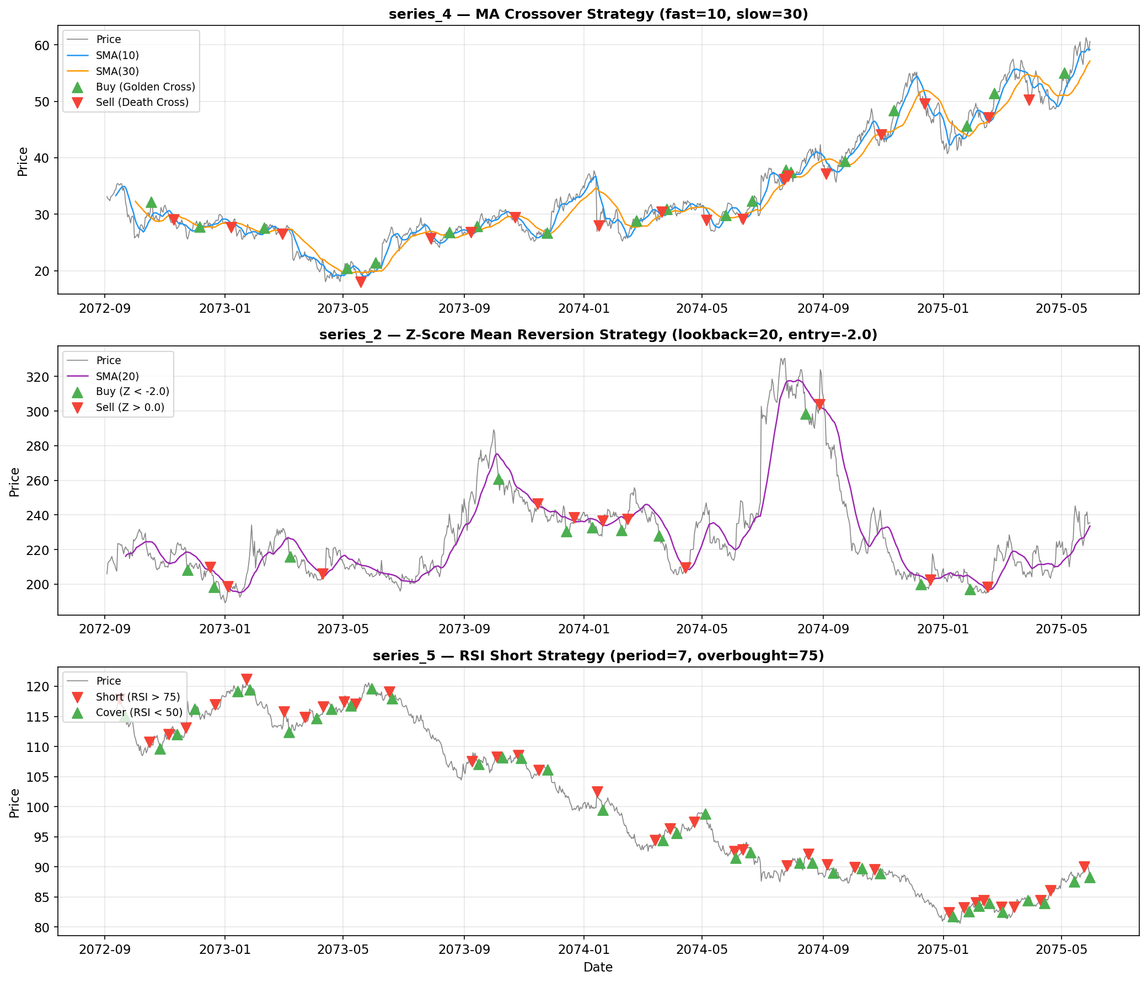

2.3.1 trend strategy variant selection
For each trending asset, four strategy variants, ma_crossover, breakout, MACD, and above_ma, were tested to find the optimal combination of parameters for each variant through grid search, and then the best variant was selected based on the comprehensive score, which is discussed in detail below.
Series_1: Breakout strategy (lookback=25). This series has a daily volatility of 1.90%, a total gain of 69.07%, a maximum drawdown of -45.88%, a skewness of up to 4.10, and a kurtosis of 61.06 (Table 2-1), indicating that the asset's price action contains frequent extreme forward jumps, i.e., "breakout" sharp rises. The optimal strategy recommended by Grid Search is above_ma (composite score of 0.429), but the above_ma strategy requires 7 consecutive days to stand above the moving average to trigger a buy signal, and for series_1, an asset characterized by sudden jumps, an excessively long confirmation period may lead to missing the best entry time for a breakout market. In contrast, breakout strategies, which enter immediately when the price breaks the previous 25-day high, better match the price behaviour characteristics of series_1 (Brock et al., 1992). Therefore, the breakout strategy was chosen over the above_ma recommended by the optimizer.
Test Set Sharpe

Series_3: Moving average confirmation strategy (above_ma, ma_period=20, confirm_days=3). This series is one of the lowest volatile trending assets among the 10 assets (daily volatility of 0.49%) but has the highest Sharpe ratio (0.80) and a Return/MaxDD of 3.57 (Table 2-2), showing a steady and low-noise uptrend. The optimisation strategy recommended by grid search is ma_crossover (overall score of 0.618), but the moving average crossover strategy is prone to frequent false signals due to small crossovers of fast- and slow-moving averages in a low-volatility environment. The moving average confirmation strategy effectively filters out short-term noise by requiring the price to stand above the SMA (20) for 3 consecutive days before triggering buying, making it more suitable for series_3 assets with stable trends but minimal volatility. In addition, the exit rules of the above_ma strategy (sell below the moving average) respond more quickly than ma_crossover's death cross signals, which helps to take profits in time when the trend reverses.
Test Set Sharpe

Series_4: Moving average crossover strategy (ma_crossover, fast=10, slow=30). This series is the asset with the highest volatility (2.77%) and the highest total return (83.03%) in the dataset (Table 2-1), showing strong trend characteristics in the wild fluctuations. Grid Search also recommended the ma_crossover strategy (composite score of 0.615), which was eventually adopted, fine-tuning only the fast line period from 15 to 10 to improve responsiveness to trend turns in series_4 sharp fluctuations. The SMA crossover strategy generates buy signals (golden crosses) and sell signals (death crosses) through SMAs (10) above and SMAs (30), which is a mechanism that effectively tracks medium-term trend direction in high-volatility environments, consistent with Jegadeesh and Titman's (1993) findings on momentum effects.
Test Set Sharpe

Series_6 and Series_ 9: Moving average confirmation strategy (above_ma). series_6 (daily volatility of 1.80%, return of 47.67%) and series_9 (daily volatility of 0.71%, return of 16.64%) both show positive trend characteristics, although the volatility varies greatly (Table 2-1). Grid search recommended series_6 using the breakout strategy (composite score of 0.485) and series_9 using the ma_crossover strategy (composite score of 0.533). Finally, the two were uniformly adjusted to the above_ma strategy because for series_6, its skewness (3.70) and kurtosis (69.65) were extremely high (Table 2-1) as the price jumped frequently. Thus the breakout strategy may generate too many transactions due to frequent false breakouts, and the multi-day confirmation mechanism of the moving average confirmation strategy could better filter these noises. For series_9, its volatility is at a moderate level (0.71%), where the moving average crossover strategy may generate crossover signals too frequently, while the confirmation mechanism of the above_ma strategy provides a more stable signal. Additionally, unifying series_6 and series_9 into the same strategy variant (with ma_period = 15 and confirm_days = 2.) simplifies the overall complexity of the strategy and reduces the risk of failure on unknown data due to overfitting individual assets.
Test Set Sharpe

Test Set Sharpe

2.3.2 Mean REVERSION STRATEGY VARIANTS SELECTION
For each mean reversion asset, four strategy variants were tested: z-score, rsi, bollinger, and ma_deviation, which are discussed in detail below.
Series_2 and Series_10: Z-Score strategy. The Return/MaxDD ratio of series_2 (14.32% total return, maximum drawdown -41.07%) and series_10 (total return 30.52%, maximum drawdown -33.83%) are 0.35 and 0.90, respectively (Table 2-2), both of which are well below the threshold of 1.1 of the trend group, indicating that the retracement component in its price trend is too significant relative to the gain, and it is more suitable for the mean reversion strategy of entering when the price deviates from the mean and exiting when it returns to the mean. Grid Search recommended the z-score strategy for both (0.482 composite score for series_2 and 0.626 for series_10 composite score) and ultimately adopted this recommendation. The Z-Score strategy judges oversold and regression timing by calculating the standard deviation of the current price relative to the rolling mean (Poterba & Summers, 1988), and Z-Score's statistical framework adaptively adjusts entry and exit thresholds for these two highly volatile and large drawdown assets. The final parameters have been conservatively adjusted compared to the optimizer recommendation: the lookback of series_2 has been shortened from 30 to 20, the entry_z has been reduced from 2.5 to 2.0, and the exit_z has been reduced from 0.5 to 0.0; the lookback of series_10 has been reduced from 30 to 25, the entry_z has been increased from 1.5 to 2.5, and the exit_z has been reduced from 0.25 to 0.0. The purpose of these adjustments is to reduce the dependence on specific distributions of the training set and improve the robustness of parameters on unknown data.
Test Set Sharpe

Note: The parameters have been adjusted to reduce the risk of overfitting.
Test Set Sharpe

Series_7: Bollinger Bands strategy (bollinger, lookback=15, std_mult=2.0). Series_7 is the asset with the lowest volatility in the data set (daily volatility of only 0.16%), with a total return of only 3.36% and a maximum drawdown of -4.87% (Table 2-1). Grid search recommends the ma_deviation strategy (Table 1.3d, composite score of 0.691), but ma_deviation uses the deviation of the fast=10 and slow=60 moving averages, with the 60-day slow moving average having a shorter effective trading period available in only 1000 trading days of data. The Bollinger Bands strategy is mathematically similar to the Z-Score but provides a more intuitive entry and exit framework with clear upper and lower bands: buy when the price falls below the lower band (mean - 2x standard deviation) and sell when it returns above the middle band (mean). For series_7 asset with extremely low volatility and price oscillations in a narrow range, the Bollinger Bands' 15-day window and 2.0x standard deviation accurately capture its minute deviations and regressions.
Test Set Sharpe

Series_8: RSI strategy (rsi_period=14, oversold=30). With a daily volatility of 0.49% and a total return of 10.91% (Table 2-1), series_8 is a moderately volatile asset with moderate gains. Grid search recommended the ma_deviation strategy (Table 1.3d, composite score 0.530), but ma_deviation only had a gain of 1.99% on the test set. In contrast, the RSI strategy follows Wilder’s (1978) Relative Strength Index framework, buying when the RSI is below 30 (oversold) and selling above 50 (returning to neutral), with concise and clear signal logic. For series_8 assets with negative skewness (-1.28) and peak (7.28), i.e., occasional sharp downward dips followed by a recovery where the RSI's oversold detection mechanism is able to identify rally opportunities after sharp declines. In addition, the RSI strategy requires only one parameter (period 14) and does not rely on the stability of rolling means and standard deviations, making it more robust on out-of-sample data.
Test Set Sharpe

2.3.3 SHORT STRATEGY SELECTION
Series_5 finally uses the RSI overbought short strategy (rsi_period=7, overbought=75, oversold=40). This series is the only asset in the dataset that shows a negative total return (-23.57%), with a Sharpe ratio of -0.71 (Table 2-1), and traditional buy-and-hold strategies are bound to lose a lot on this asset. Therefore, going short is the only reasonable trading direction. Grid Search recommended rsi_short among the four short variants (Table 2-12, composite score of 0.479) and ultimately adopted the recommendation. The RSI overbought short strategy opens a short position when the RSI(7) is above 75 (expecting the price to fall back from the overbought region) and closes the position at a profit when the RSI is below 40. The 7-day RSI period is short, able to quickly capture the series_5's short-term rally and pullback rhythm, matching the asset's moderate volatility of 0.57%.
Test Set Sharpe

Notably, the benefit gap between the training set and the test set for ma_cross_short and trend_short reached 15.20 and 19.65 percentage points, respectively, indicating a significant risk of overfitting. In contrast, the training set return (6.15%) of rsi_short is basically consistent with the test set return (7.15%), indicating that the parameters of this strategy have good out-of-sample generalisation ability. Bollinger short Loss (-0.40%) on the test set produced the worst performance and was therefore not adopted.

2.3.4 EXIT MECHANISM SELECTION: ATR STOP LOSS VS. SIGNAL-DRIVEN EXIT
In the design of the exit mechanism, three schemes were tested: no fixed stop loss (pure signal driven exit), ATR×2.0 fixed stop loss, and ATR×3.5 fixed stop loss. As shown in Table 2-13, the stop-loss threshold of ATR×2.0 is too narrow and is frequently "accidentally injured" during normal price fluctuations, resulting in the strategy exiting profitable trending positions prematurely and significantly reducing returns. The ATR×3.5 stop-loss threshold, while loose enough to avoid frequent triggers (only 9), has a yield (25.25%) slightly lower than the no-stop option (25.37%), and the PD Ratio is basically flat (4.21 vs 4.22), which does not lead to substantial improvement. Considering that increasing the stop-loss mechanism would introduce additional parameters (ATR periods and multiples), increase the risk of overfitting, and the improvement would be minimal, it was decided not to use a fixed stop. The core logic of this decision is that the exit signals of the trend strategy (such as falling below the moving average, death cross, etc.) are themselves an adaptive mechanism based on market conditions, which can exit in time when the trend reverses without additional fixed price stop loss.

2.4 POSITION MANAGEMENT RATIONALE
The position management framework of the portfolio strategy is built on three core designs: a 70% trend / 30% other capital allocation, equal weighting within groups, and target position sizing combined with a safety buffer.
Trend assets get 70% of the total capital. This follows the testing results in Section 1.5.4. The trend strategy alone made a 27.21% return. This gain is the main driver for the portfolio’s profit. In contrast, the other strategies (mean reversion and short selling) made a return of -2.67%. These strategies led to a total loss when they ran independently. Therefore, allocating most of the capital to the trend strategy is well-founded. Meanwhile, the parameter sensitivity analysis in Section 1.5.2 (Table 1.5) demonstrates that the 70/30 split achieves an optimal PD Ratio of 2.44, which provides a strong balance between absolute returns and risk-adjusted performance.
The intra-group equal weighting design, allocating 14% to each of the 5 assets in the trend group and 6% to each of the 5 assets in the other group, adheres to the principle of simplicity. In the absence of reliable predictive signals for future returns, further optimisation intra-group weights using historical data would highly likely lead to overfitting, thereby degrading performance on the unseen data in Part 3. While equal weighting loses potentially optimal intra-group allocations, it ensures the robustness and replicability of the strategy.
For order execution level, the strategy uses a method called Target Position Sizing. First, it calculates the target value for each asset. It does this by multiplying the total portfolio value by the asset's weight. Then, it divides this value by the current price to find the target number of shares. Price changes and trading costs can cause overspending. To prevent this, the strategy uses a 95% buffer. It calculates the size using this formula: (Target Value × 0.95) / Current Price. This ensures the actual order amount stays slightly below the theoretical target. Furthermore, before placing any order, the strategy uses the overspend_guard method provided by the BT396 framework. This step verifies whether the current available cash is sufficient to cover the expected cost of the order. If the check fails, the transaction is skipped, preventing forced liquidation by the framework due to overdraft.

2.5 RISK MANAGEMENT DESIGN
The risk management framework of the portfolio strategy is structured around three core layers: a signal-driven exit mechanism, the identification and mitigation of correlation risks, and an overspend check.
Section 2.3.4 explains the exit mechanism. The strategy does not use a fixed ATR stop-loss. Instead, it relies only on signals from each sub-strategy to exit. Specifically, the trend strategy closes positions if the price drops below the moving average or if a bearish crossover happens. The mean reversion strategy exits if the price returns to the mean. The short-selling strategy closes if the RSI falls back to the oversold zone. The main advantage of this method is that it is adaptable. Exit rules depend on the current market state, not on fixed price levels. This allows profits to keep growing while the trend stays strong. It also ensures the strategy exits if the trend reverses.
Regarding correlation risk, Figure 2-6 reveals the correlation structure among the assets. A significant positive correlation exists among series_7, series_8, and series_9, meaning they could drop together in the same market environment, thereby amplifying the portfolio's drawdown risk. To mitigate this, the strategy employs two approaches. First, it assigns these three assets to different strategy categories (series_9 to trend; series_7 and series_8 to mean reversion), ensuring that their entry and exit signals are not entirely synchronized. Second, it limits the overall portfolio impact of these highly correlated assets by allocating a minimal weight of 6% each to series_7 and series_8. Additionally, series_5 exhibits a negative correlation with almost all other assets; its short-selling strategy provides hedging protection when the rest of the portfolio experiences drawdowns. The moderate positive correlations between series_1 and series_2 (0.57), as well as between series_2 and series_10 (0.54), also should be noticed. However, because series_1 and series_2 belongs to different strategy types (trend and mean reversion, respectively), their holding periods do not completely overlap, thus reducing the actual correlation exposure.
Regarding capital security, the strategy verifies the sufficiency of available cash through the overspend_guard method before every order placement, thereby avoiding triggering the framework's forced liquidation mechanism.
Figure 2-6: Asset Correlation Heatmap
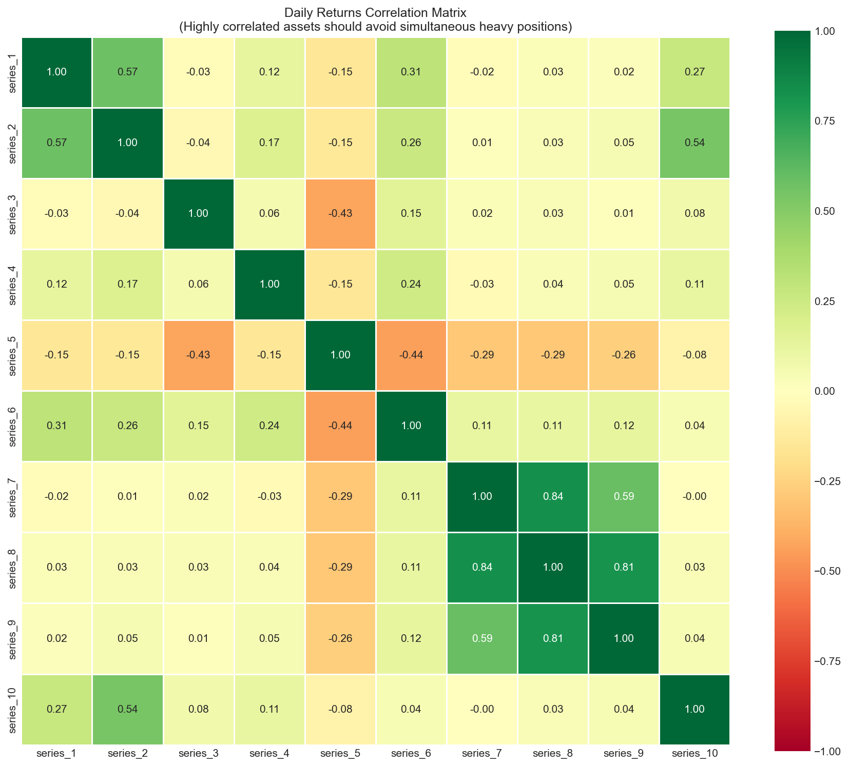

2.6 KEY CODE EXAMPLES AND EXPLANATIONS

2.6.1 TREND SIGNAL GENERATION
The get_trend_signal() method is responsible for generating buy and sell signals for trending assets, calling different trend variant logic based on the asset's strategy configuration. The following shows the code implementation of two core variants, the Breakout Strategy and the Moving Average Confirmation Strategy.
The core idea of the breakout strategy comes from the channel breakout rule of Brock et al. (1992): when the closing price breaks through the upper edge of the price channel of the previous N days, it is considered to be an uptrend and a buy signal is generated; When the close falls below the lower edge of the channel, it is considered the end of the trend, generating a sell signal. In code implementation, prev_high and prev_low use the index [-1] to take the highest/lowest price of the previous candlestick, ensuring that the price of the current candlestick is not included and avoiding look-ahead bias.
The core logic of the breakout strategy:
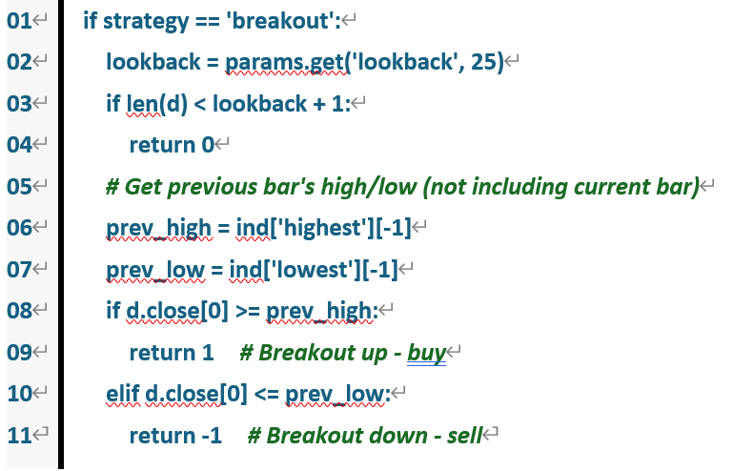
The core logic of the Moving Average Confirmation Strategy (above_ma):
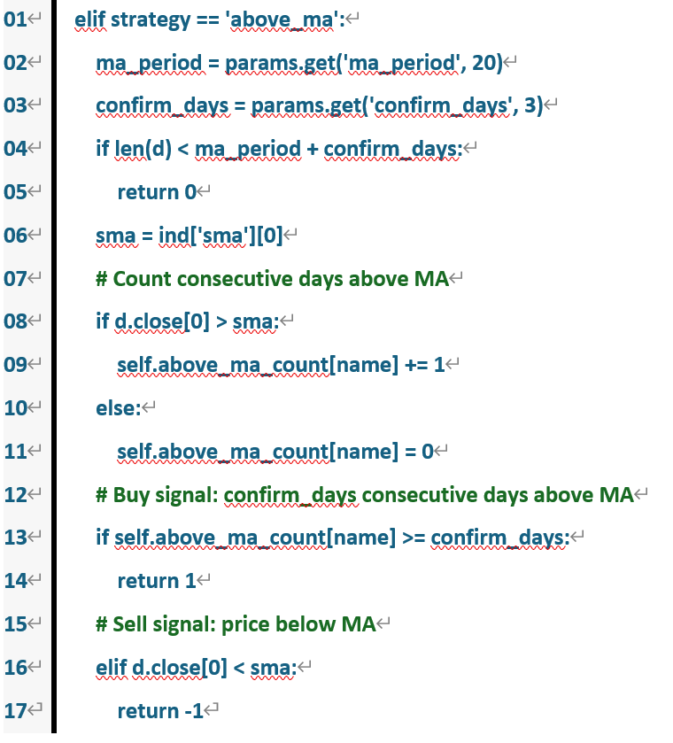

2.6.2 MEAN REVERSION SIGNAL GENERATION
The get_mr_signal() method is responsible for generating buy and sell signals for mean reversion assets. The following shows the code implementation of two core variants, the Z-Score strategy and the Bollinger Bands strategy.
The core idea of the Z-Score strategy is based on Poterba and Summers (1988) theory about price mean reversion: calculate the standard deviation degree of the current price relative to the rolling mean (Z-Score), when the Z-Score is below a negative entry threshold (such as -2.0), the price is considered to be statistically oversold, generating a buy signal; When the Z-Score rises above the exit threshold (such as 0.0, which is the mean level), the mean reversion is considered complete, generating a sell signal. The judgment of if std < 1e-10: return 0 in the code is used to prevent zeroing errors when the standard deviation approaches zero.
The Bollinger Bands strategy is mathematically similar to Z-Score but offers a more intuitive framework for the upper and lower bands through Backtrader's built-in BollingerBands indicator. Buy when the closing price falls below the lower band (mean - N times standard deviation) and sell when it returns above the middle band (mean). For series_7 asset with extremely low volatility (0.16%), the narrow channel of the Bollinger Bands can accurately detect minute price deviations and regressions.
The core logic of the Bollinger Bands strategy:
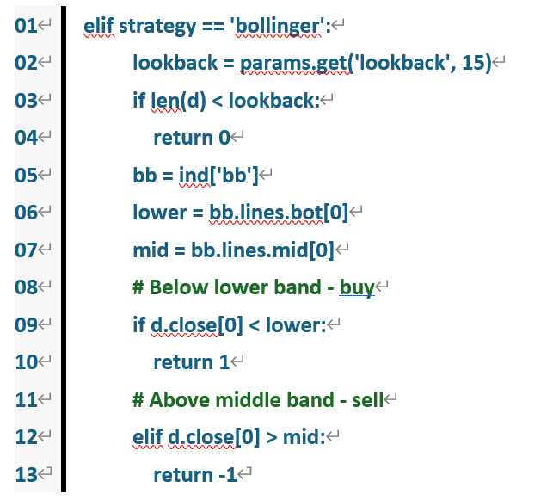

The core logic of the Z-Score strategy:
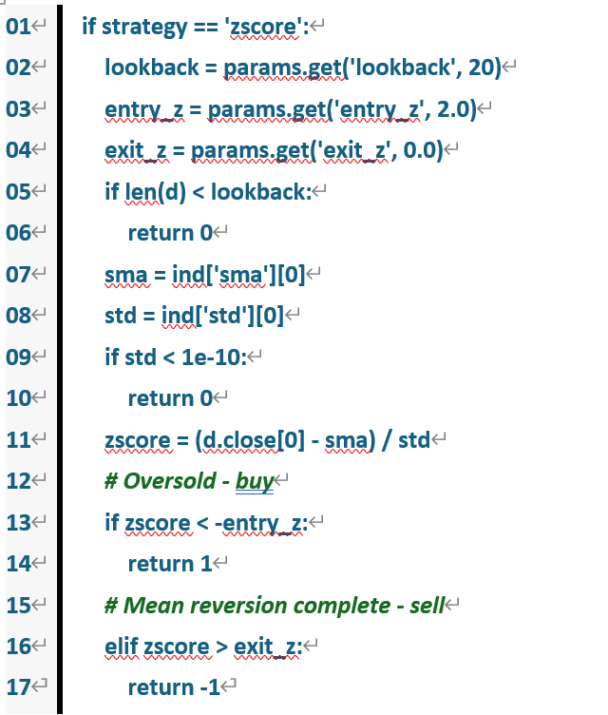

2.6.3 ORDER EXECUTION AND POSITION MANAGEMENT
The next() method is the main loop of the strategy, which executes signal generation and order placement operations on all 10 assets sequentially on each trading day. The following shows its core logic.
In code, target_value is calculated using the get_target_value(name) method, returning the total value of the current portfolio multiplied by the weight of that asset (14% for trending assets and 6% for other assets). The formula for calculating the target position size is int(target_value * 0.95 / current_price), where 0.95 is a buffer factor of 95%, ensuring that the actual order amount is slightly lower than the theoretical target, leaving room for slippage and price fluctuations. overspend_guard method verifies whether the available cash is sufficient before placing an order, and if it is insufficient, the transaction is skipped (continue) instead of forcibly placing an order that leads to an overdraft. The sell operation closes the position in full through self.place_market(d, -position) without retaining part of the position, ensuring that the position of the asset is completely exited when the exit signal is triggered.
Core logic of order placement and position management:
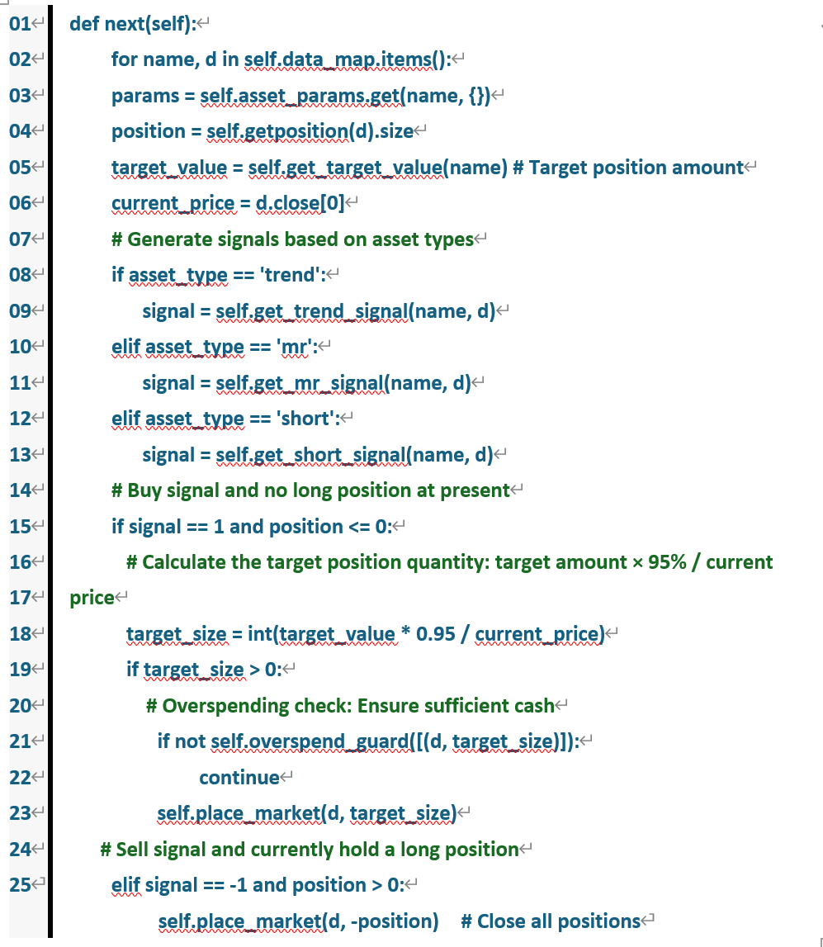

CHAPTER 3: Evaluation of Performance on Part 3 Data

3.1 Backtest Result vs. Expectations

3.1.1 EXPECTED BENCHMARKS
During the strategy development phase, reasonable expectations for out-of-sample performance were established through a range of robustness tests. The most informative of these was the validation-set test, conducted on the final 46% of the Part 2 data. This test produced a return of 14.71%, an Aggregate PD Ratio of 1.92, and an Activity of 93.41%, which together represented the most conservative lower bound of the expected performance. The result on the complete Part 2 dataset — a return of 19.55%, an Aggregate PD Ratio of 2.44, and an Activity of 96.9% — formed the upper bound of the ideal expectation. In addition, the rolling-window test showed that 9 out of 10 six-month windows were profitable (90%), with an average return of 4.65%, suggesting that the strategy should remain profitable across most market environments. The component test further confirmed that the 70/30 blended allocation produced a PD Ratio (2.44) superior to that of the non-trend-only configuration (−0.47), validating the effectiveness of the combined design.
Taken together, these results indicated that Part 3 performance was expected to fall between the validation-set level and the full-sample level, with a return in the range of 14.7% to 19.6% and an Aggregate PD Ratio between 1.9 and 2.4.

3.1.2 ACTUAL PERFORMANCE
The comparison in Table 3-2 shows that the overall Part 3 performance moved in the direction anticipated by the design. The realised return of 30.66% exceeded the expected range of 14.7% - 19.6% derived from the robustness tests, which suggests that the risk-diversification and return-generation choices made during the Part 2 development phase were effective. The Aggregate PD Ratio of 1.92 fell below the Part 2 figure of 2.44 but remained level with the conservative lower bound established by the validation-set test (1.92) and therefore stayed within a reasonable range. The decline in PD did not indicate a breakdown of the strategy; rather, it reflected the fact that the higher return was accompanied by greater volatility. Activity stood at 96.80%, almost identical to the Part 2 figure of 96.90%, indicating that the trading frequency and holding duration remained stable in Part 3, with no anomalous behaviour.
Figure 3-1: True Equity Curve on Part 3
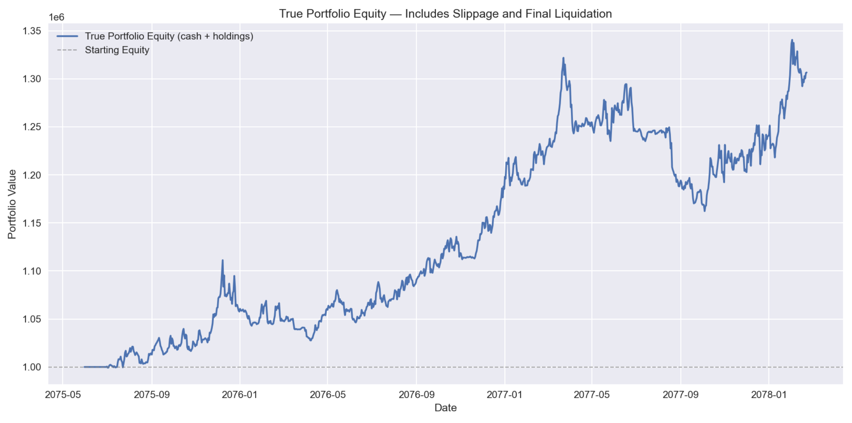
Figure 3-1 illustrates that the portfolio value remained relatively flat over the first 400 trading days, then underwent a pronounced upward trend between day 400 and day 800 and finally reached approximately 1.31 million after 1,000 trading days. Compared with Part 2, the Part 3 equity curve displayed larger fluctuations but a steeper overall ascent, reflecting the fact that the trend assets captured larger price movements in Part 3.
Figure 3-2: Portfolio Underwater Chart on Part 3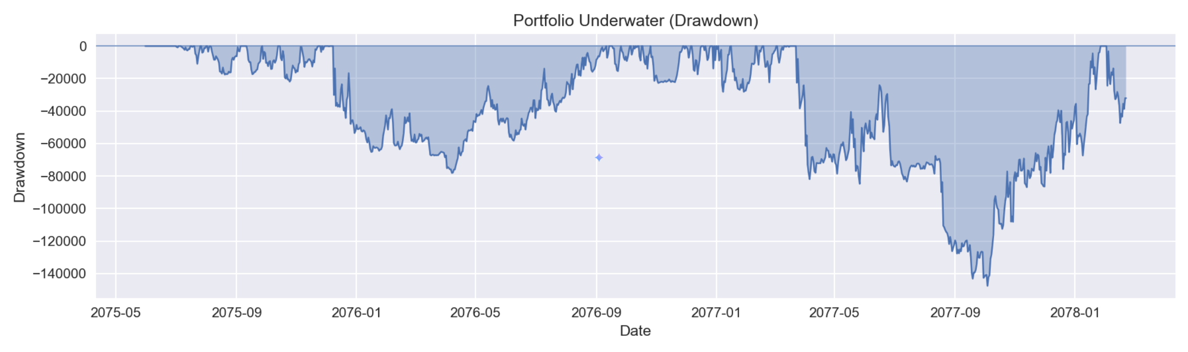
Figure 3-2 shows the portfolio drawdown as a percentage of its historical peak. Both the depth and the duration of the drawdowns in Part 3 were greater than those in Part 2, which is consistent with the earlier analysis: the Part 3 data exhibited higher volatility, and the trend assets incurred deeper drawdowns as the cost of capturing larger gains. Taken as a whole, however, the portfolio recovered from each drawdown and went on to establish new highs, and no unrecoverable drawdown occurred.

3.1.3 ASSET-LEVEL Analysis
Trend assets accounted for virtually the entire profit of the portfolio. Within this group, series_4 (ma_crossover) and series_1 (breakout) together contributed 80.6%, acting as the principal drivers of portfolio returns. The mean reversion strategies were largely ineffective in Part 3: among the four assets, only series_10 and series_7 posted small gains, while series_2 and series_8 recorded losses. The short strategy applied to series_5 produced a modest loss, and its hedging effect on the portfolio was limited.
Figure 3-3: PnL contribution by asset on Part 3
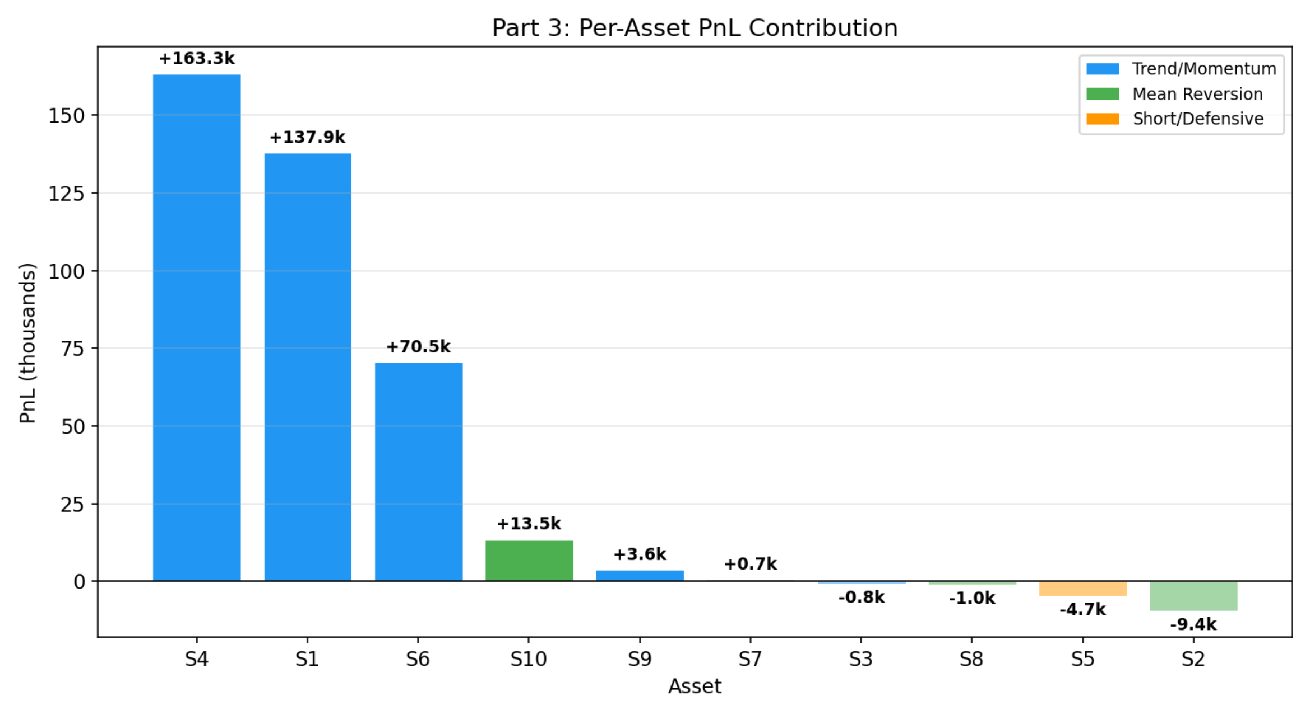
Figure 3-3 illustrates that series_4 and series_1 served as the "dual engines" of portfolio returns, while series_2 and series_5 formed a small drag on overall performance.
Figure 3-4 reveals a pronounced drift in asset behaviour between the two periods, which is the underlying reason why some strategies exceeded expectations while others underperformed. A detailed analysis is provided in Section 3.1.4.
Figure 3-4: Asset returns, Part 2 vs. Part 3
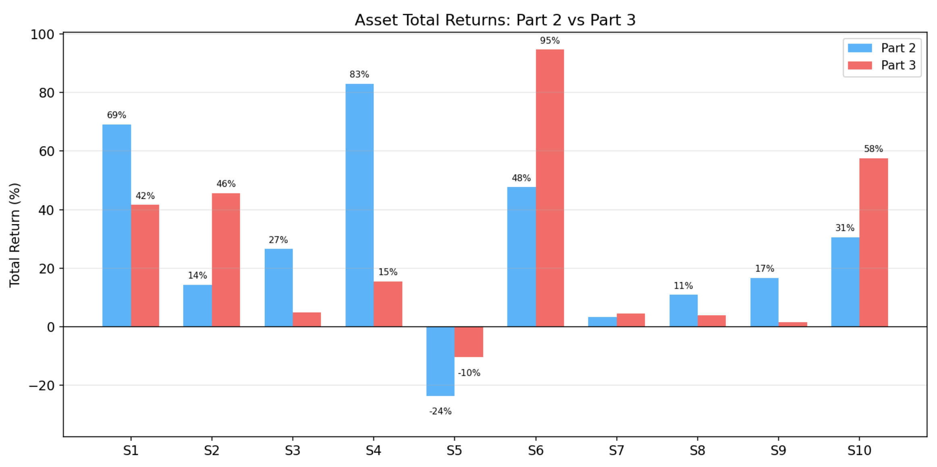
Figure 3-5 shows that the trend/momentum strategies generated 100.3% of the portfolio's returns, closely matching the structure observed in the Part 2 component test and indicating that the composition of portfolio returns remained stable across periods.
Figure 3-5: PnL contribution by strategy type
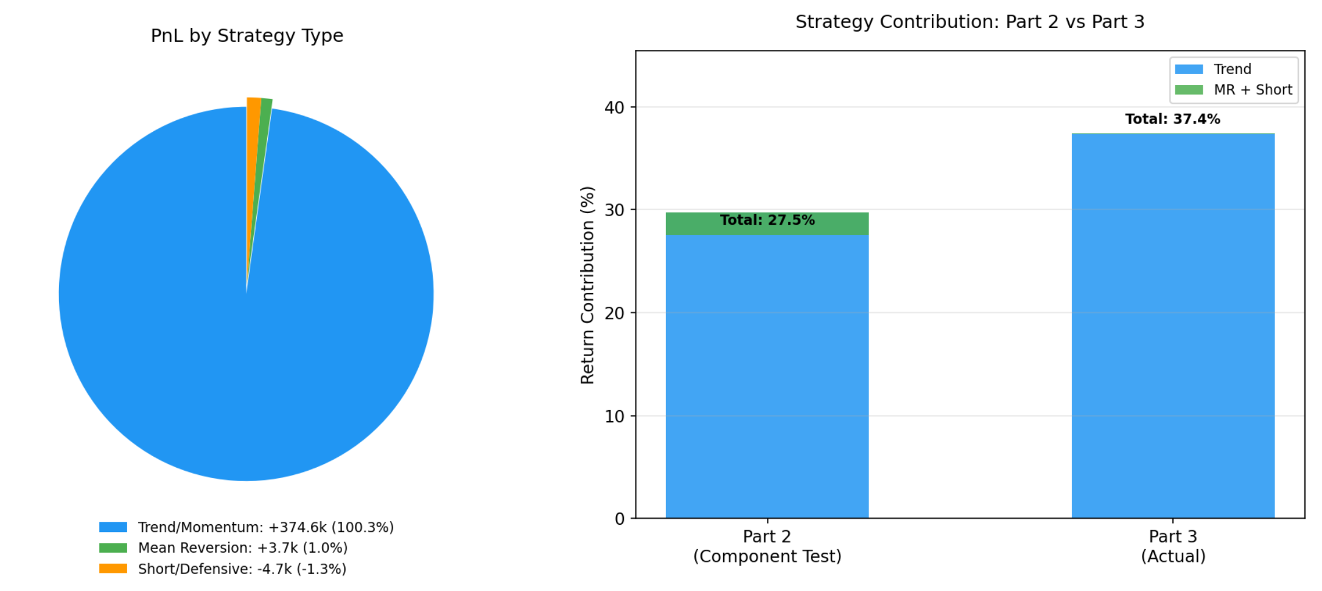
This structure is consistent with the conclusion drawn from the Part 2 component test, namely that the trend strategies constitute the core source of portfolio value. The detailed reasoning is presented in Section 3.1.4.

3.1.4 Analysis of performance variance
The primary reason behind the outsized returns, which exceeded initial expectations—lies in the significant price fluctuations of several trending assets within the Part 3 dataset. Notably, series_6 surged by 94.6% (compared to only 47.7% in Part 2), while series_1 rose by 41.6%. Trend strategies naturally benefit from high volatility: the greater the extent of price movement, the larger the profit margin the strategy can capture. Given that trending assets account for 70% of the total capital allocation, the outperformance of these specific assets directly boosted the overall portfolio return.
However, the higher returns were coupled with more pronounced drawdowns, explaining the decline in the PD Ratio relative to Part 2. In Part 3, the Maximum Drawdown for several assets deepened significantly—series_4 deepened from -49.3% to -76.6%, while series_1 shifted from -45.9% to -59.7%. This increased magnitude of drawdowns at the portfolio level expanded the denominator of the PD Ratio calculation (Return/MaxDD), resulting in a lower overall quotient. In other words, the market environment in Part 3 was more turbulent; while the strategy generated higher absolute profits, it sustained greater price fluctuations.
A more fundamental cause lies in the shift of the underlying asset behavioural patterns. When comparing the asset characteristics between Part 2 and Part 3—using the Return/MaxDD Ratio as the primary metric—it is evident that five out of the ten assets underwent a classification shift in Part 3:
Figure 3-6 presents a scatter plot illustrating the intertemporal drift of the Return/MaxDD Ratio for each asset. This visual evidence proves the behavioural shifts detailed in Table 3-4, with series_3 and series_9 exhibiting the most pronounced classification drift.
Figure 3-6: Asset Classification Drift Scatter Plot (Return/MaxDD Ratio)
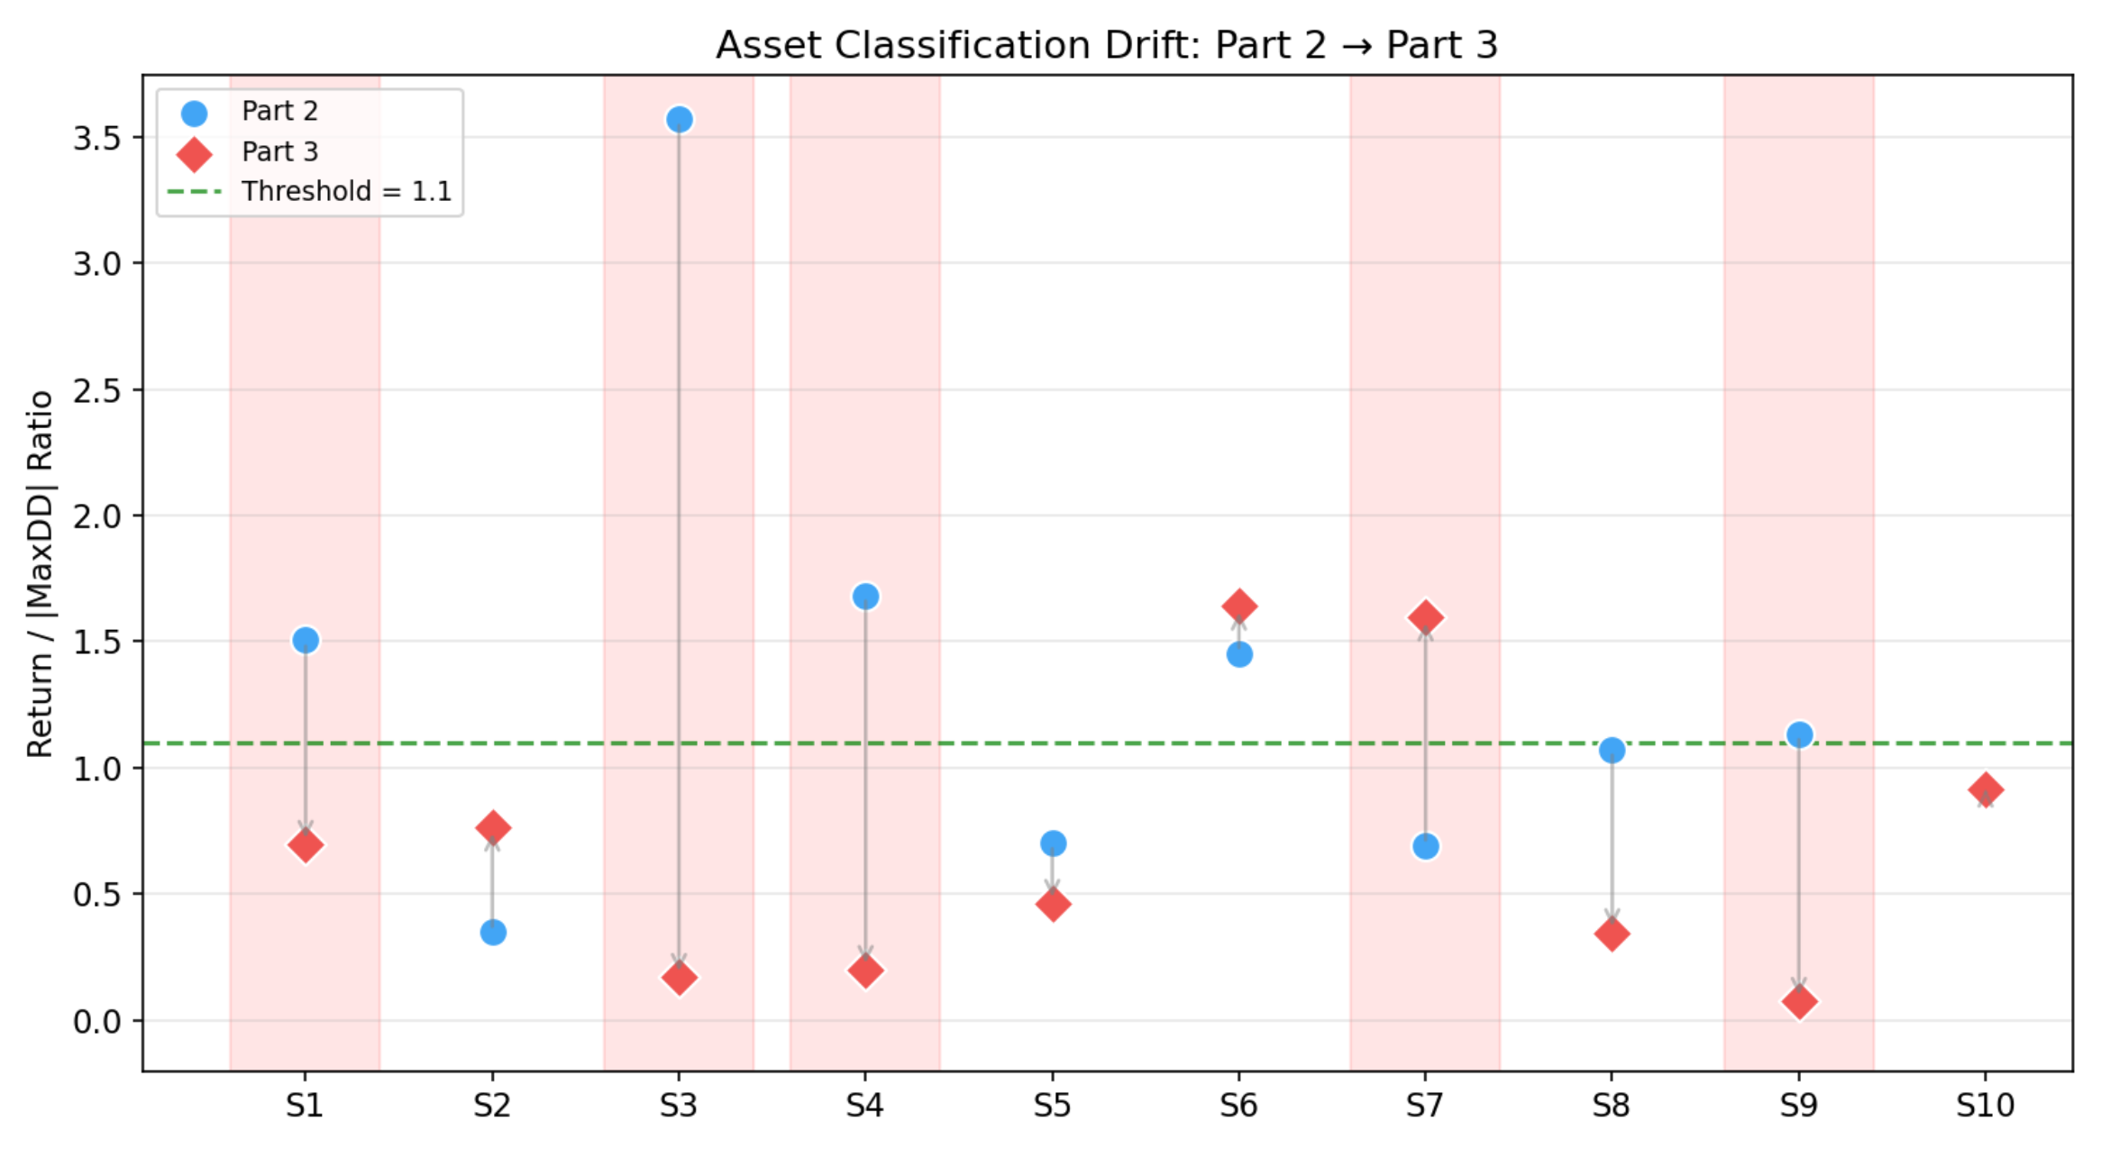
It is worth noting that, despite series_1 and series_4 no longer being statistically classified as "trending" in Part 3 (with ratios dropping to 0.70 and 0.20, respectively), their trend-following strategies remained highly profitable. Notably, series_4 even achieved the highest PD Ratio (3.96) among all assets. This suggests that the viability of trend strategies is broader than what the Return/MaxDD Ratio classification implies: as long as an asset exhibits intermittent price trends, a trend strategy can extract profit, even if the overall drawdown is substantial. A low Return/MaxDD Ratio merely reflects weak "risk-adjusted trendiness," rather than preventing profitability for trend-based approaches.
In contrast, series_3 and series_9 made almost no profit in Part 3, even though they were also given trend strategies. The difference is that series_1/4/6 still had large price gains (41.6%, 15.5%, and 94.6%), providing clear moves to catch. However, the gains for series_3/9 were very low (4.9% and 1.5%), so the above_ma strategy went in and out repeatedly without building up any net profit. This shows that the real profit potential of the asset (not the classification label) is the key factor for a strategy's success. Series_5 continued to drop in Part 3 (-10.4%), which was good for shorting. But the rsi_short strategy uses RSI signals to time trades (short at RSI > 75, close at RSI < 50) rather than holding the short position all the time. In Part 3, the RSI signals did not catch the main drops. Also, because the drop was smaller than in Part 2 (-23.6%), there was less room for error and trading costs, leading to a final loss of 4,685.

3.2 ERRORS AND LIMITATIONS

3.2.1 TECHNICAL LIMITATIONS
At the technical level, the most significant limitation was the static classification of assets. The core assumption of the strategy was that the asset characteristics identified in Part 2 would continue into Part 3. However, the actual data showed that 5 out of 10 assets experienced clear changes in their behaviour patterns. For instance, series_3 was the most stable trending asset in Part 2, with a Return/MaxDD Ratio of 3.57. In Part 3, however, its trend-following characteristics almost disappeared, and the ratio fell to 0.17. As a result, the above_ma strategy repeatedly generated buy signals and then quickly triggered sell signals, leading to a net loss of 817. This revealed a fundamental weakness of the static classification approach: it could not respond to time-varying asset behaviour. Nevertheless, the 70/30 trend-priority allocation helped the overall portfolio remain profitable, even when some asset classifications failed in Part 3. The portfolio still achieved a positive return of 30.66%.
A related issue was the vulnerability of the mean reversion strategy in trending markets. In Part 2, series_2 showed typical mean-reverting characteristics, with a moderate return of 14.3%, so it was assigned to the z-score strategy. However, in Part 3, series_2 shifted to a strong upward trend, gaining 45.7%. The z-score strategy bought when the price deviated from its mean but then exited once the z-score returned to a normal range as the price continued to rise. This prevented the strategy from capturing a full trend and resulted in a loss of 9,321. If a trend-following strategy had been applied instead, this asset could have made a positive contribution. It should be noted that the initial classification decision was still supported by the historical characteristics observed in Part 2, including a 14.3% return and a Return/MaxDD of 0.35. Therefore, the failure was mainly caused by a market regime shift, rather than a fundamental flaw in the analysis method.

3.2.2 PLANNING LIMITATION
At the planning level, the first issue was the limited coverage of robustness testing. The team designed four types of robustness tests, including time-period splitting, allocation sensitivity, rolling-window testing, and component testing. However, all these tests were based on subsets of the Part 2 data. They could verify the stability of the strategy across different slices of Part 2, but they could not detect changes in the underlying behaviour of the assets. In retrospect, an additional “asset characteristic drift test” should have been included. This test could simulate how strategy performance deteriorates when asset characteristics deviate from those observed in Part 2. For example, a block bootstrap method could be used to resample the daily return series of each asset. Scenario datasets could then be constructed by increasing volatility by 1.5 times or reducing trend strength by half. This would allow us to observe the performance decay curve of the strategy under different market-characteristic assumptions.
The second limitation was the risk caused by fixed parameters. After all strategy parameters were optimised through grid search on Part 2, they remained unchanged. Although the 70/30 train-test split helped reduce overfitting to some extent, the parameters still reflected the statistical properties of Part 2, such as volatility level and mean reversion speed. In Part 3, the volatility of some assets increased significantly. For example, the annualized volatility of series_6 rose from 28.6% to 40.0%, while that of series_10 increased from 28.3% to 37.7%. Under these new conditions, the fixed parameters may no longer have been optimal.
More importantly, the strategy lacked an early warning mechanism for parameter failure. If series_3 performed poorly during the first 200 days, there was no mechanism to reduce its allocation or pause trading. The strategy continued to follow its initial settings mechanically, regardless of changes in the market environment. This meant that the 14% allocation to series_3 was largely wasted on frequent but ineffective trades during most of Part 3. If this capital had been reallocated to better-performing assets, such as series_6, the overall portfolio return could have been further improved.

3.2.3 TEAMWORK
In terms of planning, the principal shortcoming was the lack of timeline elasticity and task redundancy. When core members faced health and remote-working constraints, project progress fell behind schedule, leaving insufficient time for logic validation. The team also did not adopt a continuous documentation approach during the research phase, which created considerable pressure in the final stage, where Part 3 performance data had to be integrated while the draft was simultaneously condensed to meet the 10,000-word limit. In terms of task allocation, the team focused excessively on parameter tuning and fell into a local-optimisation trap. No member was designated as a "Red Team" to challenge the core assumption that asset classification would remain valid, which delayed the transition towards a dynamic mechanism. The team also relied too heavily on external feedback regarding the framework's internal rules and naming conventions; when supervisor responses were delayed, decision-making stalled rather than proceeding based on internal standards.

3.3 LESSONS LEARNED AND IMPROVEMENT DIRECTION

3.3.1 CORE LESSONS
The most important lesson from the results of Part 3 is that trend following is the most reliable source of returns. Trending assets contributed 100.3% of the portfolio's profit, with series_4 moving average crossover strategy (one of the most classic trend strategies) achieving an excellent performance of PD Ratio 3.96, the highest among all assets. This shows that simple, classic trend strategies have the strongest generalisation ability across periods. In contrast, the mean reversion strategy made almost no positive contribution in Part 3. Although the short strategy also belongs to the trend following category, it is limited by the narrowing of the series_5 decline and the low allocation ratio of 6% and cannot effectively contribute profits.
At the same time, Part 3 also reveals that the non-stationarity of asset behaviour is the biggest risk factor. Trending assets in the past may not necessarily remain trending assets in the future, for example, series_3 from the "best trending asset" (ratio 3.57) in Part 2 to almost zero return in Part 3. This reminds the team that classification based on historical data can only be used as a reference and cannot be used as a permanent basis for strategy binding.
However, the results of Part 3 also validated the correctness of some design decisions. The 70/30 ratio design proved successful in Part 3: Despite the underperformance of some assets, the 70% trend ratio ensured the overall profitability of the portfolio. The conclusion of a "<3.3% change in the PD Ratio of Ratio Sensitivity" in the robustness test was validated in Part 3, and the strategy was insensitive to small changes in the ratio, which is a positive design feature. In addition, the conclusion that signal-driven exits are better than fixed stops is further supported: series_4 experienced a price retracement of -76.6% and could have been forced to close positions midway if ATR stops were used, missing out on subsequent trend profits.

3.3.2 Directions for Redesign
Combined with the specific issues exposed in Part 3, if the strategy were to be redesigned, the team would make the dynamic strategy allocation mechanism the highest priority for improvement. Specifically, the rolling return/MaxDD ratio of each asset would be recalculated every N Day (e.g., 60 days), and the strategy type is dynamically switched according to the latest characteristics. For example, if a series_2 trend enhancement (the rolling ratio rises above the threshold) is detected during Part 3 running, it can automatically switch from z-score to above_ma strategy to avoid losses from mean reversion strategies in trending markets.
In terms of position management, the team would introduce a volatility adaptive mechanism to adjust the position size using ATR or rolling volatility: Lower positions when volatility is high, and increase positions when volatility is low. Taking series_6 as an example, its annualized volatility in Part 3 (40.0%) is significantly higher than that in Part 2 (28.6%), and if the position had been automatically reduced to the original 70%, it could have significantly reduced drawdown while retaining most of the profits, thereby increasing the PD Ratio.
An effective improvement to address the vulnerability of mean reversion strategies is to add trend filters. Before the mean reversion signal is triggered, check the long-term trend direction (e.g., 100-day moving average slope) and activate the mean reversion signal only when the asset is not in a clear trend. This avoids the problem of series_2 repeatedly triggering z-score buy signals during the strong rise in Part 3. Similarly, an exit mechanism for "Decay" should be added if the cumulative return of an asset in the last N days (e.g., 120 days) is consistently negative, the position of the asset is automatically reduced to 50%, or the trade is suspended. In Part 3, if series_3 has been identified as "invalid" and suspends trading in the first 200 days, 14% of its funds can be reallocated to the better-performing trending assets, further enhancing the portfolio's returns.
Finally, in the validation phase, the scope of robustness testing should be expanded. In addition to the existing 4 types of tests (time period, ratio, rolling window, component), asset characteristic drift testing (artificially adjusting the volatility or trend strength of Part 2 data to observe the decay of the strategy's performance under different market characteristics), strategy crossover testing (running both trend and mean reversion strategies for each asset to compare which strategy is better in different market conditions), and Monte Carlo simulation (resampling the yield series using the block bootstrap method to evaluate the proportion of the strategy's performance from real market patterns while preserving the short-term autocorrelation structure).

Breakdown of the teamwork

yixuan Zhao
Zhao served as the lead programmer and led the implementation of the source code and contributed several key technical proposals at the level of strategy design and methodology.
She developed the core strategy file team2.py which translates the three sub-strategy framework and the 70/30 capital allocation scheme jointly agreed upon by the team into a unified TeamStrategy class inheriting from backtrader.bt.Strategy. She managed allocation parameters through a params dictionary, maintained per-asset technical indicators through a nested dictionary, and enforced asset-level position limits and overspending protection through the get_target_value() and overspend_guard() functions.
Parameter optimisation
She proposed the Return/MaxDD Ratio as the core asset-classification metric and determined the threshold through iterative testing. The proposal was adopted following team discussion. She then developed three independent grid-search scripts (optimize_trend_individual.py, optimize_mr_individual.py, and optimize_short_individual.py) covering all candidate strategy variants for the trend, mean-reversion, and short asset groups. To mitigate overfitting, she helped design a 70/30 training/test split and a composite scoring function that balanced in-sample fit, out-of-sample generalisation, absolute return, and drawdown control.
Robustness test
She implemented robustness_test.py according to the plan agreed by team. The script covers time-period splitting, allocation sensitivity, rolling-window analysis, and independent strategy-component testing. She also developed test_atr_stoploss.py to compare signal-driven exits against fixed ATR-based stop-loss mechanisms. data_analysis.ipynb implemented the team's statistical analysis, including descriptive statistics, OLS trend regression, ADF stationarity testing, and SMA200 consistency analysis.
She also developed generate_report_figures.py and generate_part3_figures.py for the report visualisations and authored the README.txt describing the runtime environment and execution procedure.

ao Zhang
Zhang's contributions focused on technical interpretation, strategy selection explanation, and Final Report writing. At the beginning of Semester 2, she analysed Series 01, 03, 04 and 06, mainly supporting the team’s understanding of Trend/Momentum assets, including their trend strength, volatility, and price behaviour. She also helped explain why these assets were suitable for trend-following strategies and contributed to the final asset-to-strategy mapping.
As a key contributor to Chapter 1, Zhang explained the final strategy architecture and the selection logic of the sub-strategies. She wrote the CA2 “Detailed Logic of the Three Sub-strategies” section and completed Final Report Section 1, summarising the 70/30 portfolio structure and the rationale and core logic of Breakout, Above_MA, Z-Score, Bollinger Bands, and RSI strategies.
Zhang also contributed to the Rolling Window Test and Strategy Component Independent Test analysis, explaining how robustness results supported the 70/30 mixed allocation. In Section 3.2, “Errors and Limitations”, she analysed static asset classification, regime shifts between Part 2 and 3, fixed-parameter limitations, and strategy failures caused by changing asset behaviour. She also reviewed the whole Final Report for coherence, academic expression, and formatting consistency, and served as note-taker for the first and fifth meetings in Semester 2.

Haw wong
Haw Wong’s contribution centered on qualitative strategy research and the analytical justification of the project's trading methodologies. He was primarily responsible for the research and recommendation of the Short-selling strategy, which replaced the team's original "Buy & Hold" approach for underperforming assets.
Haw identified Series_5 as the only asset with a negative total return (-23.57%) and provided the technical rationale for an RSI-based overbought shorting mechanism (7-day period, 75/40 thresholds) to profit from its consistent decline. As the lead author for Section 2.3, Haw documented the logic for matching strategies to asset characteristics, such as selecting the Breakout strategy for Series 1 to capture extreme positive skewness and the "above_ma" strategy for stable assets like Series 3. In Section 2.6, he synthesized the technical documentation for the strategy's signal generation and position management framework.
Finally, in Section 3.3, Haw directed the strategic reflection on performance, identifying trend-following as the most reliable return driver, which ultimately contributed 100.3% of portfolio profits. He pioneered a comprehensive redesign roadmap, advocating for a dynamic allocation mechanism that switches trading types every 60 days based on rolling metrics. Additionally, he proposed volatility-adaptive position sizing using ATR to reduce drawdowns during turbulent phases, ensuring the strategy remains robust against future asset behavioural drift.

yudan xue
Yudan Xue contributed to strategy logic development, risk-control design, and report writing. She analysed series_7 to series_10 together with Zhao and helped verify the asset characteristics used for strategy classification. She also applied OLS-based analysis to support the selection of series_5 for the short-selling strategy. Based on group discussions, she suggested the 95% cash buffer and the use of the overspend_guard logic to reduce the risk of overspending and forced liquidation.
In terms of optimisation, she proposed the use of grid search for systematic parameter tuning and helped develop the scoring formula used to compare candidate strategies. For the report, she drafted Sections 2.1 to 2.5 (without 2.3) and Section 3.1.4, explaining the data-analysis process, classification rationale, risk-control logic, and the effect of Part 3 volatility on strategy performance. She also worked with Haw to shorten Section 2 to meet the required word limit and served as note-taker for the Week 4 and Week 8 meetings.

References
Brock, W., Lakonishok, J. and LeBaron, B. (1992) 'Simple technical trading rules and the stochastic properties of stock returns', The Journal of Finance, 47(5), pp. 1731–1764. doi: 10.1111/j.1540-6261.1992.tb04681.x.
Jegadeesh, N. and Titman, S. (1993) 'Returns to buying winners and selling losers: implications for stock market efficiency', The Journal of Finance, 48(1), pp. 65–91. doi: 10.1111/j.1540-6261.1993.tb04702.x.
Markowitz, H. (1952) 'Portfolio selection', The Journal of Finance, 7(1), pp. 77–91. doi: 10.1111/j.1540-6261.1952.tb01525.x.
Poterba, J.M. and Summers, L.H. (1988) 'Mean reversion in stock prices: evidence and implications', Journal of Financial Economics, 22(1), pp. 27–59. doi: 10.1016/0304-405X(88)90021-9.
Wilder, J.W. (1978) New concepts in technical trading systems. Greensboro, NC: Trend Research.

